**Teaching management system.**

**Design manual.**

Class 15 Softwork A3.

20154831337 .

Name Wang Yixuan.

**the binn.**

**First, demand analysis.**

1. Target user 3 .

2. Main Function 3.

1. **Summary design.**

1. . . Module function note 3.

1.1 Assignteaching tasks ---------------------------------------------------------------------------------3.

1.2 Enroll editing ---------------------------------------------------------------------------------------3.

1.3 Score processing ---------------------------------------------------------------------------------------3 .

1.4 Results Statistical Analysis ---------------------------------------------------------------------------------4.

1.5 Student query score ---------------------------------------------------------------------------------4 .

1.6 Choose a professional mentor---------------------------------------------------------------------------------4.

2. Student Performance Management Data Flowchart 4.

**Third, the detailed structure design.**

1. E-R Chart (CDM) 4.

2. Relationship between tables (PDM) 5.

3. Table Space 5 .

4. . . User 6 .

5. . . View 7 .

6. Stored Procedure 8.

7. Function 9 .

8. Trigger 9.

**Fourth, implement the** **script.**

0. New script 11.

1. Table space 12 .

2. User 13 .

3. Table and View 15 .

4. Sample data 22 .

5. . . Stored procedure 26 .

6. Function 31 .

7. . . Trigger 33 .

**V. Debug analysis and test results.**

Commissioning analysis and test results 37.

**First, demand analysis.**

1. **The target user.**

The target users of this system are student users, teacher users and management users.

1. **The main functions.**

|  |  |
| --- | --- |
| Student user features: | 1. Query the personal file information.  2. Modify personal information.  3. Check the test results.  4. Choose courses online.  5. Query the selection information.  6. Modify the login password.  7. Check out an individual GPA.  8.Query teacher information.  9.Select a teacher as a professional tutor. |
| Teacher user features: | 1. Enter student scores.  2. Check the student's grades.  3. Modify the student's grades.  4. Query the teacher's personal information.  5. Modify the teacher's personal information.  6. Modify the course information.  7. View student selection information.  8. Enquiry Tutoring Student Information.  9. Modify Tutoring Students . |
| Management user features: | 1. Back up the database.  2. Recover the database .  3. Reverse storage .  4. Authorize for other users.  5. Modify the teaching plan.  6. Check teacher information.  7. Count student test scores.  8. Modify the account .  9. View audit information. |

1. **Summary design.**
2. **The module feature description.**
   1. Assign teaching tasks.
3. The teaching task of the teacher is entered into by the teaching management department according to the teaching task assignment form.
4. It may also be modified according to the actual situation;
5. Teachers can inquire about their teaching tasks.
   1. Select course registration.

Optional courses for each semester are derived from teaching task information. Students complete the selection course within the specified date and subject to the restrictions such as the required score, and deposit the results into the student score data sheet, and the teacher can extract the list of students from the student performance data sheet and print them.

* 1. Score processing.

After the teacher has reviewed the paper, the teacher enters the student test results for the subject and prints the submitted transcript. When the course name should appear automatically after the selection of the instructor, academic year, semester, teaching major, class, and the course name is selected, the system should automatically appear the list of all students who selected the course. If the results are missed or entered incorrectly, the teacher may modify and re-enter the grade and save the score for per manafter, after obtaining the authorization of the management department.

* 1. Statistical analysis of results.

According to the class, professional statistical courses, such as the excellent rate.

* 1. Students inquire about grades.

Students check their course scores through the campus network or the Internet.

* 1. Choose a professional mentor.

Students select a professional tutor by querying teacher information. The teacher can modify the students he tutors.

1. **Student performance management data flowchart.**



**Third, the detailed design.**

1. **E-R diagram (CDM)**



1. **Relationships between tables (PDM)**



1. **Table space.**

**3.1** **Table space allocation.**

The teaching management database EnterDB.dlpu.dalian stores seven tables with a total storage capacity of approximately 280MB.

(1)Data files, redo log files, control files, and related parameter files should, in principle, be stored as separately as possible and not on the same disk or partition.

(2) Because of the frequent score queries, the data and index should be stored in the data table space and the index table space, respectively.

(3) The primary data is stored in a table space.

|  |  |  |  |  |  |
| --- | --- | --- | --- | --- | --- |
| **Table name.** | **The mode of ownership.** | **Corresponding to the department.** | **The corresponding table space.** | **The initial size.** | **how to grow.** |
| DB_COLLEGE .  DB_MAJOR .  DB_STUDENT .  DB_TEACHER .  DB_COURSE.  DB_TEACH_COURSE .  DB. . .MAJOR_TEACH. | Staffuser.  Staffuser.  Staffuser.  Staffuser.  Staffuser.  Staffuser.  Staffuser. | All colleges and universities.  Colleges and universities.  The whole school students.  The whole school teacher.  All courses in the school.  All majors.  All professional tutors and tutors with students. | tbs_main.  tbs_main.  tbs_main.  tbs_main.  tbs_main.  tbs_main.  tbs_main. | 500M .  500M.  500M .  500M .  500M .  500M .  500M . | Automatic.  Automatic.  Automatic.  Automatic.  Automatic.  Automatic.  Automatic. |
| DB_GRADE . | Staffuser. | School of Biological Engineering.  School of Food Science and Engineering. | tbs_bio_foo. | 200M . | Automatic. |
| School of Information Science and Engineering.  School of Materials Science and Engineering. | tbs_infor_mati. | 200M . | Automatic. |
| College of Art and Design.  Costume Institute.  Business School. | tbs_art_fash_busi. | 200M . | Automatic. |

**3.2 Table spaces and files.**

|  |  |  |  |  |  |
| --- | --- | --- | --- | --- | --- |
| **Table space.** | **Type.** | **The corresponding file.** | **File size(MB).** | **Increase in growth (%)** . | **how to grow.** |
| tbs_main. | Permanent/online. | tbs_main1.ora.  tbs_main2.ora. | 250。  250。 | 10。  10。 | Automatic.  Automatic. |
| tbs_bio_foo. | Permanent/online. | tbs_bio_foo1.ora.  tbs_bio_foo2.ora. | 100。  100。 | 10。  10。 | Automatic.  Automatic. |
| tbs_infor_mati. | Permanent/online. | tbs_infor_mati1.ora.  tbs_infor_mati2.ora. | 100。  100。 | 10。  10。 | Automatic.  Automatic. |
| tbs_art_fash_busi. | Permanent/online. | tbs_art_fash_busi1.ora.  tbs_art_fash_busi2.ora. | 100。  100。 | 10。  10。 | Automatic.  Automatic. |
| tbs_teach_std. | Permanent/online. | tbs_teach_std1.ora.  tbs_teach_std2.ora. | 100。  100。 | 10。  10。 | Automatic.  Automatic. |
| tbs_index. | Permanent/online. | tbs_index1.ora.  tbs_index2.ora. | 100。  100。 | 10。  10。 | Automatic.  Automatic. |
| tbs_temp. | Temporary/online. | tbs_temp1.ora.  tbs_temp2.ora. | 100。  100。 | 10。  10。 | Automatic.  Automatic. |

1. **User.**

**4.1 The correspondence of the table space with the user and the table.**

The teaching management database EnterDB.dlpu.dalian has five database users.

|  |  |  |  |
| --- | --- | --- | --- |
| **The database user.** | **The table you own.** | **The default table space for the table.** | **The program object.** |
| staffuser. | DB_COLLEGE .  DB_MAJOR .  DB_STUDENT .  DB_TEACHER .  DB_TEACH_COURSE .  DB_COURSE.  DB. . .MAJOR_TEACH. | tbs_main. | Triggers, stored procedures, storage functions, packages, database links, and more. |
| DB_GRADE (partitiontable). ) | tbs_bio_foo. |  |
| tbs_infor_mati. |
| tbs_art_fash_busi. |
| dbdatauser .  dbsysuser . |  | tbs_main. |  |
| teauser . | DB_FACULTY_PER. | tbs_teach_std. | Some application objects. |
| stduser . | DB_STUDENT_PER. |

**4.2 Permissions between the user and the table.**

|  |  |  |  |  |  |
| --- | --- | --- | --- | --- | --- |
| **The database user.**  **Table data.** | **teauser** . | **stduser** . | **staffuser.** | **dbdatauser** . | **dbsysuser** . |
| db_college. | S. |  | SIUD. | S. | SX . |
| db_major. | S. |  | SIUD. | S. | SX . |
| db_Student. |  | SU . | SIUD. | S. | SX . |
| db_teacher. | SU . |  | SIUD. | S. | SX . |
| db_course. | S. | S. | SIUD. | S. | SX . |
| db_grade. | SU . | SU . |  | S. | SX . |
| db_teach_course. | S. | S. | SIUD. | S. | SX . |
| db_faculty_permi. | SU . |  | SIUD. | S. | SX . |
| db_student_permi. |  | SU . | SIUD. | S. | SX . |
| db_major_teacher . | SU . | SU . | SIUD. | S. | SX . |

**4.3 Initial assignment of user passwords, permissions, and roles.**

|  |  |  |  |
| --- | --- | --- | --- |
| **The user name.** | **Password.** | **The role granted.** | **The system permissions granted.** |
| staffuser. | staffuser. | CONNECT; RESOURCE. | Create function; Create view;  Create Package;  Drop table; Alter table. |
| teauser . | teauser . | CONNECT; RESOURCE. | Create view;  Create synonym. |
| stduser . | stduser . | CONNECT; RESOURCE. | Create view;  Create synonym. |
| dbdatauser . | dbdatauser . | DATAPUMP_EXP_FULL_DATABASE;  DATAPUMP_IMP_FULL_DATABASE;  EXP_FULL_DATABASE;  IMP_FULL_DATABASE; RESOURCE. | EXPORT FULL DATABASE.  IMPORT FULL DATABAS. |
| dbsysuser . | dbsysuser . | Dba. |  |

1. **View.**

There are two types of users: teachers and students.

**5.1 Information that teauser** **queries and can change.**

Teacher user teauser queries and can change some information in staffuser mode.

|  |  |  |  |
| --- | --- | --- | --- |
| **Define the view name.** | **The column of the query.** | **The columns that can be changed.** | **Related tables.** |
| vt_teach_colleg. | work_id,，t_namet_name,t_titlest_titles,major_namemajor_name,college_namecollege_name,t_address,，t_telephone,，t_positiont_position,t_email. |  | db_teacher.  db_major.  db_college. |
| vt_teach_upd. |  | t_address,，t_email.  t_telephone,，t_position. | db_teacher. |
| vt_ teach_cs. | course_no,，work_idwork_id,course_namecourse_name,launch_yearlaunch_year,launch_term,，executed_plan. |  | db_teach_course. |
| vt_teach_grade. | register_no,，course_namecourse_name,t_name,，credit,,registered_date,，registered_yearregistered_year,final_Grade, and final_Grade.  registered_term,，makeup_flag. |  | db_grade.  db_teacher.  db_Student. |
| vt_grade_upd. |  | s_mail_address.  s_postcode.  s_address,，s_tele.，  s_email. | db_grade. |

**5.2 stuser queries** **and changes** to information.

Student users can query their own information, course and selection results, teaching tasks undertaken by teachers, etc.;

|  |  |  |  |
| --- | --- | --- | --- |
| **Define the view name.** | **The column of the query.** | **The columns that can be changed.** | **Related tables.** |
| vs_grade_teach. | register_no,，course_name.，  registered_date,，registered_year, credit,， .  registered_term, t_name, final_grade, makeup_flag. |  | db_grade.  db_teacher. |
| vs_grade_upd. |  | course_name,，registered_date.，  work_id,,registered_term,,registered_year. | db_grade. |
| vs_student. | register_no,s_names_name,s_gender,,s_class,,s_teles_tele,s_dateofbirth,, s_address,，s_postcodes_postcode,s_email s_mail_address. |  | db_Student. |
| vs_student_upd. |  | s_mail_address,，s_postcode,， .  s_address,，s_tele,，s_email. | db_Student. |

1. **Store the procedure.**

**6.1 Some of the stored procedures associated** with **stuser.**

|  |  |  |  |
| --- | --- | --- | --- |
| **Define the stored procedure name.** | **Function.** | **Related tables and columns.** | **The user that belongs.** |
| p_query_std_in. | Check student personal information. | Related table:db_student .  Query:register_no .  Output:s_address, s_postcode, .  s_mail_address, s_tele, s_email. | staffuser. |
| p_upd_std_inf. | Modify student personal information. | Related table:db_student .  Query:register_no .  Update:s_address, s_postcode, .  s_mail_address, s_tele, s_email. | staffuser. |
| p_query_std_grade. | Check your exam results. | Related table:db_grade .  Query:register_no and course_name. | staffuser. |
| p_ins_upd_course. | Choose a course online. | Related tables:db_student,，db_teacher,，db_teach_course,，db_grade. | staffuser. |
| p_cancel_reg_course. | Sign out of the selected course. | Related tables:db_student,，db_major,，db_teach_course,，db_grade. | staffuser. |
| p_upd_std_pwd. | Modify the login password. | Related table:db_student_per .  Query:register_no,，login_pwd_s.  Update:login_pwd_ . | stduser . |
| p_std_tot_gpa. | Query GPA. | Related table: db_grade .  Query:register_no . | staffuser . |
| p_ins_maj_tea . | Choose a professional mentor. | Related table:db_student,，db_teacher,db_major_teacher. | staffuser . |

**6.2 Part** of **the** **stored procedure related to** **teauser.**

|  |  |  |  |
| --- | --- | --- | --- |
| **Define the stored procedure name.** | **Function.** | **Related tables and columns.** | **The user that belongs.** |
| p_query_tea_grade. | Check student results. | Related tables:db_student,，db_major,，db_teacher,，db_grade.  Query:register_no, work_id, .  course_name. | staffuser. |
| p_insert_tea_grade. | Enter student scores. | Related table:db_grade . | staffuser. |
| p_upd_tea_grade. | Modify student performance. | Related table:db_grade . | staffuser. |
| p_upd_tea_pwd. | Modify the password. | Related table:db_faculty_per .  Query:work_id,，login_pwd_f.  Update:login_pwd_f . | teauser. |
| p_upd_staf_course. | Modify the teaching plan. | Related tables:db_teach_course,，db_course.  Query:work_id,，course_no.  Update:course_no,，course_name. | staffuser. |
| psdele_maj_std. | Remove tutoring students. | Related table:db_major_teacher . | staffuser . |

1. **Function.**

**7.1 The functions and functions required.**

|  |  |  |  |
| --- | --- | --- | --- |
| **Define the function name.** | **Function.** | **Related tables and columns.** | **The user that belongs.** |
| fun_query_std_gra. | Query the test scores of the single subject. | Related table:db_grade .  Query:register_no and course_name. | staffuser. |
| fun_std_avg_gra. | Check students' average grades by semester. | Related table:db_grade .  Query:register_no and course_name. | staffuser. |
| fun_std_total_avg_gra. | Check the average grades of students for all courses. | Related table:db_grade .  Query:register_no and course_name. | staffuser. |
| fun_std_tot_gpa. | Query a student's GPA. | Related table:db_grade .  Query:register_no . | staffuser. |
| fun_std_term_avg_gra. | Check the average grade of students by major and semester. | Related table:db_grade .  Query:register_no,，registered_term. | staffuser . |

1. **Trigger.**

**8.1 Some of the triggers associated** with **the** **user's staffuser.**

|  |  |  |
| --- | --- | --- |
| **Define the trigger name.** | **Function.** | **The user that belongs.** |
| tri_startup _db. | Record when the database was started, the user, and so on. | sys. |
| tri_shutdown_db. | Record when the database was closed, the user, and so on. | sys. |
| Tri _login_user. | Automatically log the login system user information, including login IP, host name, login time, user name, etc. | sys. |
| Tri _logout_user. | Record user information for logging out of the system, including logoff IP,host name, logout time, user name, and so on. | sys. |
| tri_restrict_upd_time. | The database db_grade tables cannot be updated on Saturdays and Sundays from 8 a.m. to 5 p.m. | staffuser. |
| tri_dele_faculty_his. | Automatically record information about departing teachers. | staffuser. |
| Tri _logon_scheme. | The system automatically records user information when you log on to a user. | staffuser. |
| Tri _logoff_scheme. | When a user logs off, the user logs off automatically, the user name, and so on. | staffuser. |
| tri_aud_sche_operation. | Record the user's DDL actions. | staffuser. |

1. **Implement the script.**

**New script:**

**Create a professional mentor list:db_major_teacher.**

CREATE TABLE db_major_teacher (

WORK_ID CHAR (6) NOT NULL,

REGISTER_NO CHAR (12) NOT NULL,

CONSTRAINT PK_RNO_WID PRIMARY KEY (REGISTER_NO, WORK_ID) VALIDATE,

CONSTRAINT FK_MT_REGISTER_NO FOREIGN KEY (REGISTER_NO) REFERENCES DB_STUDENT (REGISTER_NO) VALIDATE,

CONSTRAINT FK_MT_WID FOREIGN KEY(WORK_ID) REFERENCES DB_TEACHER (WORK_ID) VALIDATE)

ORGANIZATION INDEX TABLESPACE TBS_MAIN.

PCTFREE 10.

INITRANS 50.

MAXTRANS 4.

STORAGE (BUFFER_POOL KEEP)

LOGGING NOCOMPRESS.

PARALLEL.

/

**Stored procedures:**

**Students choose a professional tutor:p_ins_maj_tea.**

CREATE OR REPLACE PROCEDURE p_ins_maj_tea.

(v_work_id db_major_teacher.work?id%type,

v_reg_no db_major_teacher. Register_no%type.

)

AS.

BEGIN.

INSERT INTO db_major_teacher (work_id, register_no)

VALUES (v_work_id, v_reg_no);

END p_ins_maj_tea;

/

**Teacher sedits students:p_dele_maj_std.**

CREATE OR REPLACE PROCEDURE P_DELE_MAJ_STD (

v_work_id IN db_major_teacher.work.id%type,

v_reg_no IN db_major_teacher.register?no%type.

)

AS.

BEGIN.

DELETE db_major_teacher.

WHERE register_no v_reg_no and work_id-v_work_id;

IF SQL%NOTFOUND THEN.

DBMS_OUTPUT. PUT_LINE ('The student doesn't exist! ');

END IF;

COMMIT;

END p_dele_maj_std;

/

**Check student GPA:：p_std_tot_gpa.**

CREATE OR REPLACE PROCEDURE P_STD_TOT_GPA (

v_reg_no IN db_grade.register?no%type,

v_gpa OUT number.

)

AS.

BEGIN.

v_gpa: s--fun_std_tot_gpa (v_reg_no), 2);

END p_std_tot_gpa;

/

**1.Create a table space.**

**1_tbs_main.sql.**

CREATE SMALLFILE TABLESPACE Tbs_main.

DATAFILE.

'C: s/app?james_000?oradata?EnterDB?Tbs_main1.ora' SIZE 250M.

AUTOEXTEND ON.

NEXT 25M.

MAXSIZE UNLIMITED,

'C: s/appjames_000?oradata?EnterDB?Tbs_main2.ora' SIZE 250M.

AUTOEXTEND ON.

NEXT 25K.

MAXSIZE UNLIMITED.

LOGGING.

EXTENT MANAGEMENT LOCAL.

SEGMENT SPACE MANAGEMENT AUTO.

/

**2_tbs_bio_foo.sql.**

CREATE SMALLFILE TABLESPACE Tbs_bio_foo DATAFILE.

'C: s/appjames_000?oradata?enterDB?Tbs_bio_foo1.ora' SIZE 100M.

AUTOEXTEND ON.

NEXT 10M.

MAXSIZE UNLIMITED,

'C: s/app?james_000?oradata?EnterDB?Tbs_bio_foo2.ora' SIZE 100M.

AUTOEXTEND ON.

NEXT 10M.

MAXSIZE UNLIMITED.

LOGGING.

EXTENT MANAGEMENT LOCAL.

SEGMENT SPACE MANAGEMENT AUTO.

**3_tbs_infor_mati.sql.**

CREATE SMALLFILE TABLESPACE TBS_INFOR_MATI DATAFILE.

'C: s/james_000?oradata?EnterDB?Tbs_infor_mati1.ora'oradata\EnterDBSIZE 100M.

AUTOEXTEND ON.

NEXT 10M.

MAXSIZE UNLIMITED,

'C: s/app,james_000?oradata?EnterDB?Tbs_infor_mati2.ora'oradata\EnterDBSIZE 100M.

AUTOEXTEND ON.

NEXT 10M.

MAXSIZE UNLIMITED.

LOGGING.

EXTENT MANAGEMENT LOCAL.

SEGMENT SPACE MANAGEMENT AUTO.

/

**4_tbs_art_fash_busi.sql.**

CREATE SMALLFILE TABLESPACE Tbs_art_fash_busi.

DATAFILE.

'C: s/james_000?oradata?EnterDB?Tbs_art_fash_busi1.ora'oradata\EnterDBSIZE 100M.

AUTOEXTEND ON.

NEXT 10M.

MAXSIZE UNLIMITED,

'C: s/app james_000?oradata?EnterDB?Tbs_art_fash_busi2.ora'oradata\EnterDBSIZE 100M.

AUTOEXTEND ON.

NEXT 10M.

MAXSIZE UNLIMITED.

LOGGING.

EXTENT MANAGEMENT LOCAL.

SEGMENT SPACE MANAGEMENT AUTO.

/

**5_tbs_teach_std.sql.**

CREATE SMALLFILE TABLESPACE Tbs_teach_std.

DATAFILE.

'C: s/james_000?oradata?EnterDB?Tbs_teach_std1.ora'oradata\EnterDBSIZE 100M.

AUTOEXTEND ON.

NEXT 10M.

MAXSIZE UNLIMITED,

'C: s/app?james_000?oradata?EnterDB?Tbs_teach_std2.ora'oradata\EnterDBSIZE 100M.

AUTOEXTEND ON.

NEXT 10M.

MAXSIZE UNLIMITED.

LOGGING.

EXTENT MANAGEMENT LOCAL.

SEGMENT SPACE MANAGEMENT AUTO.

**6_tbs_index.sql.**

CREATE SMALLFILE TABLESPACE Tbs_index.

DATAFILE 'C:/app.james_000/oradata?EnterDB?tbs_index1.ora'oradata\EnterDBSIZE 100M, .

'C: s/james_000?oradata?EnterDB?tbs_index2.ora'oradata\EnterDBSIZE 100M.

LOGGING.

EXTENT MANAGEMENT LOCAL.

SEGMENT SPACE MANAGEMENT AUTO.

/

ALTER DATABASE.

DATAFILE 'C: sapps james_000oradatasenterDBs.TBS_INDEX2. ORA' .

AUTOEXTENSION ON NEXT 10M.

/

ALTER DATABASE.

DATAFILE 'C:'james_000'oradata?enterDB?TBS_INDEX1.oradata\EnterDB ORA' .

AUTOEXTENSION ON NEXT 10M.

/

**7_tbs_temp.sql.**

CREATE SMALLFILE TEMPORARY TABLESPACE "TBS_TEMP"

TEMPFILE.

'C: s/app,james_000?oradata?EnterDB?tbs_temp1'oradata\EnterDBSIZE 100M.

AUTOEXTEND ON.

NEXT 10M.

MAXSIZE UNLIMITED, .

'C: s/james_000?oradata?EnterDB?tbs_temp2'oradata\EnterDBSIZE 100M.

AUTOEXTEND ON.

NEXT 10M.

MAXSIZE UNLIMITED.

EXTENT MANAGEMENT LOCAL.

UNIFORM SIZE 1M.

/

**2. Create a database user.**

**1_staffuser.sql.**

CREATE USER STAFFUSER PROFILE DEFAULT AYDBY "STAFFUSER123".

DEFAULT TABLESPACE tbs_main.

TEMPORARY TABLESPACE tbs_temp.

QUOTA UNLIMITED ON tbs_art_fash_busi.

QUOTA UNLIMITED ON tbs_bio_foo.

QUOTA UNLIMITED ON tbs_index.

QUOTA UNLIMITED ON TBS_INFOR_MATI.

QUOTA UNLIMITED ON tbs_main.

QUOTA UNLIMITED ON tbs_teach_std.

ACCOUNT UNLOCK.

/

GRANT CREATE INDEXTYPE TO STAFFUSER .

/

GRANT CREATE VIEW TO STAFFuser .

/

GRANT CONNECT TO STAFFuser .

/

GRANT RESOURCE TO STAFFUSER .

/

**2_teauser.sql.**

CREATE USER TEAuser PROFILE DEFAULT AYDED BY "teauser123" .

DEFAULT TABLESPACE tbs_teach_std.

TEMPORARY TABLESPACE tbs_temp.

QUOTA UNLIMITED ON tbs_art_fash_busi.

QUOTA UNLIMITED ON tbs_bio_foo.

QUOTA UNLIMITED ON tbs_index.

QUOTA UNLIMITED ON TBS_INFOR_MATI.

QUOTA UNLIMITED ON tbs_main.

QUOTA UNLIMITED ON tbs_main.

ACCOUNT UNLOCK.

/

GRANT Create synonym to teauser.

/

GRANT CREATE VIEW TO TEAuser.

/

GRANT CONNECT TO TEAuser.

/

GRANT RESOURCE TO TEAuser .

/

GRANT SELECT ON staffuser.db_college TO teauser.

/

GRANT SELECT ON staffuser.db_grade TO teauser.

/

GRANT UPDATE ON staffuser.db_grade TO teauser.

/

GRANT SELECT ON staffuser.db_major to teauser.

/

GRANT SELECT ON staffuser.db_student TO teauser.

/

GRANT SELECT ON staffuser.db_teacher TO teauser.

/

GRANT UPDATE ON staffuser.db_teacher TO teauser.

/

GRANT SELECT ON staffuser.db_teach_course TO teauser.

/

**3_stduser.sql.**

CREATE USER STDUSER PROFILE DEFAULT AESAUED BY "STDUSER123".

DEFAULT TABLESPACE tbs_teach_std.

TEMPORARY TABLESPACE tbs_temp.

QUOTA UNLIMITED ON tbs_art_fash_busi.

QUOTA UNLIMITED ON tbs_bio_foo.

QUOTA UNLIMITED ON tbs_index.

QUOTA UNLIMITED ON TBS_INFOR_MATI.

QUOTA UNLIMITED ON tbs_main.

QUOTA UNLIMITED ON tbs_main.

ACCOUNT UNLOCK.

/

GRANT Create synonym TO stduser .

/

GRANT CREATE VIEW TO STDUSER .

/

GRANT CONNECT TO STUSER .

/

GRANT RESOURCE TO STUSER .

/

GRANT DELETE ON ONUSER STAFF. DB_GRADE TO STDUSER.

/

GRANT INSERT ON STAFFUSER. DB_GRADE TO STDUSER.

/

GRANT SELECT ON ONSTAFF STAFF. DB_GRADE TO STDUSER.

/

GRANT SELECT ON ONSTAFF STAFF. DB_STUDENT TO STDUSER.

/

GRANT UPDATE ON ONUSER STAFF. DB_STUDENT TO STDUSER.

/

GRANT SELECT ON ONSTAFF STAFF. DB_TEACHER TO STDUSER.

/

**4_dbdatauser.sql.**

CREATE USER DBDATAUSER PROFILE DEFAULT ALYSSBY "DBDATAUSER123"

DEFAULT TABLESPACE TBS_MAIN.

TEMPORARY TABLESPACE TBS_TEMP.

QUOTA UNLIMITED ON TBS_ART_FASH_BUSI.

QUOTA UNLIMITED ON TBS_BIO_FOO.

QUOTA UNLIMITED ON TBS_INDEX.

QUOTA UNLIMITED ON TBS_INFOR_MATI.

QUOTA UNLIMITED ON TBS_MAIN.

QUOTA UNLIMITED ON TBS_TEACH_STD.

ACCOUNT UNLOCK.

/

GRANT EXPORT FULL DATABASE TO DBDATAUSER.

/

GRANT IMPORT FULL DATABASE TO DBDATAUSER.

/

GRANT "CONNECT" TO DBDATAUSER.

/

GRANT DATAPUMP_EXP_FULL_DATABASE TO dbdatauser.

/

GRANT DATAPUMP_IMP_FULL_DATABASE TO dbdatauser.

/

GRANT EXP_FULL_DATABASE TO dbdatauser.

/

GRANT IMP_FULL_DATABASE TO dbdatauser.

/

GRANT RESOURCE TO DBDATAUSER.

/

**5_dbsysuser.sql.**

CREATE USER DBsysuser PROFILE DEFAULT ESAD BY "dbsysuser123" .

DEFAULT TABLESPACE tbs_main.

TEMPORARY TABLESPACE tbs_temp.

ACCOUNT UNLOCK.

/

GRANT SYSDBA TO dbsysuser.

/

GRANT CONNECT TO DBsysuser.

/

GRANT DBA to dbsysuser.

/

GRANT RESOURCE TO DBsysuser.

/

**3-Table and view.**

**1_db_college.sql.**

CREATE TABLE DB_COLLEGE ( .

college_no CHAR(2)NOT NULL, .

college_name VARCHAR2 (20), .

setting_quota NUMBER (4), .

current_quota NUMBER (4), .

major_number NUMBER (2), .

CONSTRAINT pk_college_no JRY KEY (COLLEGE_NO) VALIDATE ) .

TABLESPACE TBS_MAIN.

INITRANS 1 MAXTRANS 4 PARALLEL.

/

**2_db_major.sql.**

CREATE TABLEUSER STAFFUSER. DB_MAJOR (

MAJOR_NO CHAR (4), .

MAJOR_NAME VARCHAR2 (20), .

COLLEGE_NO CHAR(2), .

CONSTRAINT FK_COLLEGE_NO FOREIGN KEY (COLLEGE_NO) REFERENCES STAFFUSER. DB_COLLEGE (COLLEGE_NO) VALIDATE,

CONSTRAINT PK_MAJOR_NO PRIMARY KEY (MAJOR_NO).

TABLESPACE TBS_MAIN.

PCTFREE 10.

INITRANS 1.

MAXTRANS 255.

STORAGE (BUFFER_POOL DEFAULT).

LOGGING NOCOMPRESS.

/

**3_db_student.sql.**

CREATE TABLE db_Student.

Register_no Char(12) not null.

Major_no Char (4), .

S_name Char(8), .

S_Gender Char(2), .

S_Dateofbirth Date, .

S_class Char(2), .

S_address Varchar2 (40), .

S_postcode Char(6), .

S_mail_address Varchar2 (60), .

S_tele Char(11), .

S_email Varchar2 (20), .

CONSTRAINT fk_s_major_no FOREIGN KEY (major_no)) .

REFERENCES db_major(major_no)(VALIDATE, .

CONSTRAINT pk_register_no CONSTRAINT PRIMARY KEY(register_no)). . KEY(

TABLESPACE tbs_main.

PCTFREE 10.

PCTUSED 50.

INITRANS 2.

MAXTRANS 4.

PARALLEL.

STORAGE (BUFFER_POOL KEEP)

LOGGING NOCOMPRESS.

/

**4_db_teacher.sql.**

CREATE TABLE db_teacher( .

Work_id CHAR (6) NOT NULL, .

T_name CHAR (8), .

T_Titles CHAR (6), .

Major_no CHAR (4), .

college_no CHAR(2), .

T_address VARCHAR2 (40), .

T_telephone CHAR (11).

T_position CHAR (10), .

T_email VARCHAR2 (20), .

CONSTRAINT fk_f_major_no FOREIGN KEY (major_no).)

REFERENCES db_major(major_no)(VALIDATE, .

CONSTRAINT fk_f_colle_no FOREIGN KEY (COLLEGE_NO)) .

REFERENCES db_college(college_no)(VALIDATE, .

CONSTRAINT pk_work_id CONSTRAINT PRIMARY KEY(work_id)) VALIDATE) ). . KEY(

TABLESPACE tbs_main.

PCTFREE 10.

PCTUSED 40.

INITRANS 2.

MAXTRANS 4.

PARALLEL.

STORAGE (BUFFER_POOL DEFAULT)

LOGGING NOCOMPRESS.

/

**5_db_course.sql.**

CREATE TABLE db_course( .

course_no VARCHAR2 (9) NOT NULL, .

Major_no CHAR (4), .

term_no CHAR (1), .

year_no CHAR (9), .

course_name VARCHAR2 (20), .

credit NUMBER (4), .

Planned_hour NUMBER (3), .

Lab_hour NUMBER (2), .

week_hour NUMBER (4,1), .

course_type CHAR (4), .

exam_type CHAR (4), .

remarks VARCHAR2 (12), .

CONSTRAINT fk_c_major_no FOREIGN KEY (major_no)REFERENCES db_major(major_no)VALIDATE. (

CONSTRAINT pk_course_no CONSTRAINT PRIMARY KEY(course_no)) VALIDATE) ). . . . KEY(

TABLESPACE tbs_main.

PCTFREE 10.

PCTUSED 50.

INITRANS 2.

MAXTRANS 4.

PARALLEL.

STORAGE (BUFFER_POOL KEEP)

LOGGING NOCOMPRESS.

/

**6_db_teach_course.sql.**

CREATE TABLE db_teach_course( .

course_no VARCHAR2 (9) NOT NULL, .

Work_id CHAR (6) NOT NULL, .

course_name VARCHAR2 (20), .

launch_year CHAR (9), .

launch_term CHAR (1), .

Executed_plan VARCHAR2 (20), .

CONSTRAINT pk_cs_no_wk_id PRIMARY KEY(course_no, work_id)VALIDATE, . KEY(

CONSTRAINT fk_tc_curse_no FOREIGN KEY (course_no) DB_COURSE db_course(COURSE_NO) VALIDATE .

CONSTRAINT fk_tc_work_id FOREIGN KEY (work_id)REFERENCES db_teacher(work_id)VALIDATE). (

TABLESPACE tbs_main.

PCTFREE 10.

PCTUSED 40.

INITRANS 2.

MAXTRANS 4.

PARALLEL.

STORAGE (BUFFER_POOL DEFAULT)

LOGGING NOCOMPRESS.

/

**7_db_grade.sql.**

CREATE TABLE DB_GRADE ( .

REGISTER_NO CHAR(12) NOT NULL, .

COURSE_NO VARCHAR2 (9) NOT NULL,

WORK_ID CHAR (6) NOT NULL.

COLLEGE_NO CHAR(2), .

COURSE_NAME VARCHAR2 (20),

REGISTERED_DATE DATE,

REGISTERED_YEAR CHAR (9), .

REGISTERED_TERM CHAR (1), .

FINAL_GRADE NUMBER(6,2), .

MAKEUP_FLAG CHAR (1), .

CREDIT NUMBER(4,1), .

CONSTRAINT PK_RNO_WID_CNO PRIMARY KEY(COLLEGE_NO, REGISTER_NO, COURSE_NO, WORK_ID) VALIDATE, .

CONSTRAINT FK_REGISTER_NO FOREIGN KEY (REGISTER_NO) REFERENCES DB_STUDENT (REGISTER_NO) VALIDATE,

CONSTRAINT FK_GRADE_WID FOREIGN KEY (WORK_ID) REFERENCES DB_TEACHER (WORK_ID) VALIDATE,

CONSTRAINT FK_GRADE_CNO FOREIGN KEY(COURSE_NO) REFERENCES DB_COURSE (COURSE_NO) VALIDATE,

CONSTRAINT FK_F_COLLEGE_NO FOREIGN KEY (COLLEGE_NO) REFERENCES DB_COLLEGE (COLLEGE_NO) VALIDATE)

ORGANIZATION INDEX TABLESPACE TBS_MAIN.

PCTFREE 5.

INITRANS 1.

MAXTRANS 30.

STORAGE (BUFFER_POOL KEEP).

PARTITION BY LIST (COLLEGE_NO) (

PARTITION DB_GRADE_P1 VALUES ('04', '05', '7') TABLESPACE TBS_ART_FASH_BUSI,

PARTITION DB_GRADE_P2 VALUES ('01', '02') TABLESPACE TBS_BIO_FOO,

PARTITION DB_GRADE_P3 VALUES ('03', '06') TABLESPACE TBS_INFOR_MATI,

PARTITION DB_GRADE_P4 VALUES (DEFAULT) TABLESPACE TBS_TEACH_STD)

PARALLEL.

/

**8_db_faculty_per.sql.**

CREATE TABLE DB_FACULTY_PER ( .

WORK_ID CHAR (6) NOT NULL.

LOGIN_PWD_F VARCHAR2 (20), .

PWD_TIP1_F VARCHAR2 (20), .

PWD_ANSWER1_F VARCHAR2 (16),

PASSOWOD_TIP2_F VARCHAR2 (20), .

PWD_ANSWER2_F VARCHAR2 (16),

CONSTRAINT PK_FACULTY_PER_WID PRIMARY KEY (WORK_ID).

TABLESPACE TBS_TEACH_STD.

PARALLEL.

/

**9_db_student_per.sql.**

CREATE TABLE DB_STUDENT_PER ( .

REGISTER_NO CHAR (12), .

LOGIN_PWD_S VARCHAR2 (20), .

PWD_TIP1_S VARCHAR2 (20), .

PWD_ANSWER1_S VARCHAR2 (16), .

PASSOWOD_TIP2_S VARCHAR2 (20), .

PWD_ANSWER2_S VARCHAR2 (16), .

CONSTRAINT PK_STUDENT_PER_REGIST_NO PRIMARY KEY (REGISTER_NO).

TABLESPACE TBS_TEACH_STD.

PCTFREE 10.

INITRANS 1.

MAXTRANS 255.

STORAGE (BUFFER_POOL DEFAULT).

LOGGING NOCOMPRESS.

PARALLEL.

/

**10_vt_teach_colleg.sql.**

CREATE VIEW vt_teach_colleg AS.

SELECT t.work_id, t.t_name, t.t_titles, m.major_name, c.college_name, t.t_address, t.t_telephone, t.t_position, t.t_email.

From staffuser.db_teacher t, staffuser.db_major m, staffuser.db_college c.

WHERE t.major_nosm.major_no and t.college_no s=c.college_no;;

**11_vt_teach_upd.sql.**

CREATE VIEW vt_teach_upd AS.

SELECT work_id, t_name, t_titles, t_position, t_address, t_telephone, t_email.

From staffuser.db_teacher;;

**12_vt_teach_cs.sql.**

CREATE VIEW vt_teach_cs AS.

select course_nocourse_no,work_idwork_id,course_name,，launch_year,，launch_term,，executed_plan.

From staffuser.db_teach_course;;

**13_vt_teach_grade.sql.**

CREATE VIEW vt_teach_grade AS.

SELECT s.s_name,，g.course_nameg.course_name,t.t_namet.t_name,g.registered_dateg.registered_year,g.registered_yearg.registered_year,g.final_Grade,，g.registered_term,，g.makeup_flag, g.credit.

From staffuser.db_grade g,，staffuser.db_teacher t,，staffuser.db_Student s.

WHERE g.work_ids=t.work_id and g.register_noss.register_no;;

**14_vt_grade_upd.sql.**

CREATE VIEW vt_grade_upd AS.

SELECT register_no, registered_term, final_Grade, makeup_flag.

From staffuser.db_grade;;

**15_vs_grade_teach.sql.**

CREATE VIEW vs_grade_teach AS.

SELECT g.register_no,，g.course_nameg.course_name,g.registered_dateg.registered_date,g.registered_yearg.registered_year,g.registered_term,，g.final_grade,，g.makeup_flag,，g.credit,，t.t_name.

FROM staffuser.db_grade g,，staffuser.db_teacher t.

WHERE g.work_idst.work_id;;

**16_vs_grade_upd.sql.**

CREATE VIEW vs_grade_upd AS.

SELECT course_namecourse_name,registered_date,，work_id,，registered_year,，registered_term,，credit.

From staffuser.db_grade;;

**17_vs_student.sql.**

CREATE VIEW vs_student AS.

SELECT register_noregister_no,s_gender,，s_dateofbirth，s_dateofbirth, s_class s_address,，s_postcodes_address,，s_name,s_name，s_mail_address,，s_tele,，s_email.

From staffuser.db_Student;;

**18_vs_student_upd.sql.**

CREATE VIEW vs_student_upd AS.

SELECT s_mail_address,，s_postcode,，s_address,，s_tele,，s_email.

From staffuser.db_Student;;

**4. Sample data.**

**1_insert_db_college.sql.**

INSERT INTO db_college(college_no, college_name, Major_number)VALUES ('01', 'Institute of Bioengineering,'2). ',2); (

INSERT INTO db_college(college_no, college_name, Major_number)VALUES ('02', 'Food Science and Engineering Academy', 2). (

INSERT INTO DB_COLLEGE(COLLEGE_NO, COLLEGE_NAME, MAJOR_NUMBER)VALUES ('03', 'SCHOOL OF INFORMATION SCIENCE AND ENGINEERING,5); ',5); (

INSERT INTO db_college(college_no, college_name, Major_number)VALUES ('04', 'Academy of Art and( Design,' 4). 艺术设计学

INSERT INTO db_college(college_no, college_name, Major_number)VALUES ('05', 'Costume ( 服装学院 Institute,' 5).

INSERT INTO db_college(college_no, college_name, Major_number)VALUES ('06', 'Institute of Materials Science and Engineering', 4). (

INSERT INTO db_college(college_no, college_name, Major_number)VALUES ('07', 'Business ( 商务学院 School,' 6);

commit;

/

**2_insert_db_major.sql.**

INSERT INTO db_major VALUES ('0101', 'Bioengineering', '01').

INSERT INTO DB_MAJOR VALUES ('0102', 'Biotechnology', '01'). 生物技术

INSERT INTO db_major VALUES ('0201', 'Food Quality and Safety', '02').

INSERT INTO DB_MAJOR VALUES ('0202', 'Food Science and Engineering', '02').

INSERT INTO db_major VALUES ('0301', 'Mathematics', '03'). 数学

INSERT INTO db_major VALUES ('0302', 'Physics', '03'). 物理学

INSERT INTO db_major VALUES ('0303', 'Computer Science and Technology', '03').

INSERT INTO db_major VALUES ('0304', 'Electronic Information Engineering', '03').

INSERT INTO db_major VALUES ('0305', 'Communication Engineering', '03').

INSERT INTO db_major VALUES ('0401', 'Environmental Art Design', '04'). 环境艺术设计

INSERT INTO db_major VALUES ('0402', 'Visual Communication Design', '04'). 视觉传达设计

INSERT INTO db_major VALUES ('0403', 'Digital Media Art', '04'). 数字媒体艺术

INSERT INTO db_major VALUES ('0404', 'Sculpture', 雕塑 '04').

INSERT INTO DB_MAJOR VALUES ('0405', 'Industrial Engineering', '04').

INSERT INTO db_major VALUES ('0501', 'Costume Art Design', '05'). 服装艺术设计

INSERT INTO db_major VALUES ('0502', 'Costume Performance Professional', '05'). 服装表演专业

INSERT INTO db_major VALUES ('0503', 'Jewelry Design', '05').

INSERT INTO db_major VALUES ('0504', 'Image Design', '05'). 形象设计

INSERT INTO DB_MAJOR VALUES ('0505', 'Photography', '05').

INSERT INTO db_major VALUES ('0601', 'Chemical Engineering and Process,'06').

INSERT INTO db_major VALUES ('0602', 'Materials Science and Technology', '06').

INSERT INTO db_major VALUES ('0701', 'Information Management System', '07'). 信息管理系统

INSERT INTO DB_MAJOR VALUES ('0702', 'Human Resource 人力资源管理 Management', '07').

INSERT INTO db_major VALUES ('0703', 'E-Commerce', '07').

INSERT INTO db_major VALUES ('0704', 'Logistics Management', '07').

commit;

/

**3_insert_db_student.sql.**

insert into db_student(REGISTER_NO, MAJOR_NO, S_NAME, S_GENDER, S_DATEOFBIRTH, S_CLASS, S_ADDRESS, S_POSTCODE, S_MAIL_ADDRESS, S_TELE, S_EMAIL).

values ('20153010101', '0101', 号 号 2360 'Wang Xiaoming', 'Male', 男 '01-Jan-96', 月 '1',','2360 Jinhai Road, Shanghai Pudong New Area, '200000',','12345678909','111@sspu.com',',', 2360 '12345678909','111@sspu.com'). 上海市浦东新区金海路

insert into db_student(REGISTER_NO, MAJOR_NO, S_NAME, S_GENDER, S_DATEOFBIRTH, S_CLASS, S_ADDRESS, S_POSTCODE, S_MAIL_ADDRESS, S_TELE, S_EMAIL).

values ('201530101102', '0101', 号 号 月 'Money Heng', 'Male', 男 'December-April -96', '1',',','2360 2360 Jinhai Road, Shanghai Pudong New Area, 2360,', '12345645609','222@sspu.com').,""""""""""""""""""""""""""""""""""""""""""""""""""""""""""""""""""""""""""""""""""""""""""""""""""""""""""""""""""""""""""""""""""""""""""""""""""""""""""""""""""""""""""""""""""""""""""""""" ','200000','

insert into db_student(REGISTER_NO, MAJOR_NO, S_NAME, S_GENDER, S_DATEOFBIRTH, S_CLASS, S_ADDRESS, S_POSTCODE, S_MAIL_ADDRESS, S_TELE, S_EMAIL).

values ('201530101403', '0101', 号 号 月 'Wang Lin', 'Male', 男 '03-June -97', '4', '2360 Jinhai Road, Shanghai Pudong New 2360 Area,', 上海市浦东新区金海路 '2360', '12345678678','333@sspu.com'). ','200000','

insert into db_student(REGISTER_NO, MAJOR_NO, S_NAME, S_GENDER, S_DATEOFBIRTH, S_CLASS, S_ADDRESS, S_POSTCODE, S_MAIL_ADDRESS, S_TELE, S_EMAIL).

values ('201520102301', 号 '0102301', 号 月 'Li Damin', 'Male', 男 '01-December -92', '3', '2360 Jinhai Road, Shanghai Pudong New Area,', '2360 Jinhai Road, '12345678909','444@sspu.com');,'""""""""""""""""""""""""""""""""""""""""""""""""""""""""""""""""""""""""""""""""""""""""""""""""""""""""""""""""""""""""""""""""""""""""""""""""""""""""""""""""""""""""""""""""""""""""""""""" ','200000',' ','12345678909','444@sspu.com');

insert into db_student(REGISTER_NO, MAJOR_NO, S_NAME, S_GENDER, S_DATEOFBIRTH, S_CLASS, S_ADDRESS, S_POSTCODE, S_MAIL_ADDRESS, S_TELE, S_EMAIL).

values ('201520102143', '0102', 号 号 'Zhao San', 'Male', 男 '21-Nov-91', 月 '1',',','2360 Jinhai Road, Shanghai Pudong New Area, 上海市浦东新区金海路 2360,'12345678909','555@sspu.com',','"""""""""""""""""""""""""""""""""""""""""""""""""""""""""""""""""""""""""""""""""""""""""""""""""""""""""""""""""""""""""""""""""""""""""""""""""""""""""""""""""""""""""""""""""""""""""""""""" 2360 ','200000',' ','12345678909','555@sspu.com');

insert into db_student(REGISTER_NO, MAJOR_NO, S_NAME, S_GENDER, S_DATEOFBIRTH, S_CLASS, S_ADDRESS, S_POSTCODE, S_MAIL_ADDRESS, S_TELE, S_EMAIL).

2360 values ('20152020154', '0201', 号 'Zhang Lili', 'Women', 女 '04-October 月 -93','1',','2360 Jinhai Road, Shanghai Pudong New Area, 号 2360 '200000',','12345678909','666@sspu.com',',', '12345678909','666@sspu.com',',','"""""""""""""""""""""""""""""""""""""""""""""""""""""""""""""""""""""""""""""""""""""""""""""""""""""""""""""""""""""""""""""""""""""""""""""""""""""""""""""""""""""""""""""""""""" 上海市浦东新区金海路

insert into db_student(REGISTER_NO, MAJOR_NO, S_NAME, S_GENDER, S_DATEOFBIRTH, S_CLASS, S_ADDRESS, S_POSTCODE, S_MAIL_ADDRESS, S_TELE, S_EMAIL).

values ('201540302107', '0302', 号 'Wang Junfeng', 号 男 'Male', '02-Jan 月 -92', '1',','2360 Jinhai Road, Shanghai Pudong New Area, 2360 '2000000', ',' '2360','12345678909','777@sspu.com',""""""""""""""""""""""""""""""""""""""""""""""""""""""""""""""""""""""""""""""""""""""""""""""""""""""""""""""""""""""""""""""""""""""""""""""""""""""""""""""""""""""""""""""""""""""""" ','200000',' 上海市浦东新区金海路 2360 ','12345678909','777@sspu.com');

insert into db_student(REGISTER_NO, MAJOR_NO, S_NAME, S_GENDER, S_DATEOFBIRTH, S_CLASS, S_ADDRESS, S_POSTCODE, S_MAIL_ADDRESS, S_TELE, S_EMAIL).

values ('201540401329', '0401', 号 'Liu Defu', 月 号 'Male', 男 '04-July -90', '3', '2360 Jinhai Road, Shanghai Pudong New Area,', '200000', '2360','12345678909','888@sspu.com'). 上海市浦东新区金海路 2360 ','12345678909','888@sspu.com');

insert into db_student(REGISTER_NO, MAJOR_NO, S_NAME, S_GENDER, S_DATEOFBIRTH, S_CLASS, S_ADDRESS, S_POSTCODE, S_MAIL_ADDRESS, S_TELE, S_EMAIL).

values ('201540502210', '0502', 号 号 'Chen Shufen', 'Women', 女 '03-Jan-90', 月 '2',',','2360 Jinhai Road, Shanghai Pudong New Area, 2360 上海市浦东新区金海路 2360,'"12345678909','999@sspu.com',"""""""""""""""""""""""""""""""""""""""""""""""""""""""""""""""""""""""""""""""""""""""""""""""""""""""""""""""""""""""""""""""""""""""""""""""""""""""""""""""""""""""""""""""""""""""""""""""""" ','200000',' ','12345678909','999@sspu.com');

insert into db_student(REGISTER_NO, MAJOR_NO, S_NAME, S_GENDER, S_DATEOFBIRTH, S_CLASS, S_ADDRESS, S_POSTCODE, S_MAIL_ADDRESS, S_TELE, S_EMAIL).

号 values ('201500601901', '0601', 号 'Wu Jianfei', 'Male', 男 '01-March 月 -96', '9', '2360 2360 Jinhai Road, Shanghai Pudong New Area,', '2360','12345678909','233@sspu.com'). ','200000',' ','12345678909','233@sspu.com');

commit;

/

**4_insert_db_teacher.sql.**

insert into db_teacher(work_id, t_name, t_email)values ('050011', 'Liu Jian', 'ian@sspu.cn'). (

insert into db_teacher(work_id, t_name, t_email)values ('030034', 'Zhang ( 张海燕 Haiyan', 'zhaiy@sspu.cn').

insert into db_teacher(work_id, t_name, t_email)values ('030023', 'Lee Laughs', 'ly@sspu.cn'). (

insert into db_teacher(work_id, t_name, t_email)values ('030024', 'Zhao Ximan', 'zhaoxin@sspu.cn'). (

insert into db_teacher(work_id, t_name, t_email)values ('020013', 'Zhang ( 张仁 Ren', 'zhangrs@sspu.cn');

insert into db_teacher(work_id, t_name, t_email)values ('060015', 'Liu Bowei', 'lb@sspu.com'). (

insert into db_teacher(work_id, t_name, t_email)values ('070001', 'Li Xuzhi', 'li@sspu.cn'); (

insert into db_teacher(work_id, t_name, t_email)values ('020003', 'Zhang Jia( 张加和 and', 'zhh@sspu.cn');

insert into db_teacher(work_id, t_name, t_email)values ('030038', 'Li ( 李露露 Lulu', 'll@sspu.cn').

insert into db_teacher(work_id, t_name, t_email)values ('040030', 'Shi Deyi', 'sy@sspu.cn'). (

commit.

/

**5_insert_db_course.sql.**

insert into db_course(course_no, Major_no,course_name) values ('PHY638',',','"University Physics 1'"). (

insert into db_course(course_no, Major_no,course_name) values ('PHY639',','','"University Physics 2'"). (

insert into db_course(course_no, Major_no, course_name))( values ('MATH033', '0301', 'Probability Theory and Mathematical Statistics'); ');

insert into db_course(course_no, Major_no,course_name)( values ('CS270', '0303', 'data 数据结构 structure');

insert into db_course(course_no, Major_no,course_name) values ('CS079', '0303', 'Digital ( Circuits and Digital Logic');

insert into db_course(course_no, Major_no,course_name) values ('CS243', '0303', 'Compilation ( 编译原理 Principles').

insert into db_course(course_no, Major_no,course_name) values ('CS244', '0303', 'Database ( 数据库原理 Principles');

insert into db_course(course_no, Major_no,course_name) values ('CS328', '0303', 'Computer Composition( 计算机组成原理 Principles').

insert into db_course(course_no, Major_no,course_name)( values ('CS449', '0303', 'Computer Network'). 计算机网络

insert into db_course(course_no, Major_no,course_name) values ('CS446', '0303', 'Web Development( Technology Foundation').

insert into db_course(course_no, Major_no,course_name) values ('CS426', '0303', 'Advanced Database( 高级数据库应用 Application');

insert into db_course(course_no, Major_no,course_name)( values ('CS448', '0303', 'Embedded System Foundation').

insert into db_course(course_no, Major_no,course_name) values ('CS473', '0303', 'Software Quality Assurance and Testing'). '); (

insert into db_course(course_no, Major_no,course_name) values ('CS449', '0303', 'Software Development Case( 软件开发案例分析 Study').

insert into db_course(course_no, Major_no,course_name)( values ('CS479', '0303', 'Embedded Operating 嵌入式操作系统 System');

insert into db_course(course_no, Major_no,course_name)( values ('CS690', '0303', 'Cybersecurity Technology'); ');

insert into db_course(course_no, Major_no, course_name)) values ('COM813', '0305', 'Internet of Things Theory and Connected Technologies'); '); (

insert into db_course(course_no, Major_no,course_name) values ('COM8011', '0305', 'Material Information( 物联信息安全 Security');

insert into db_course(course_no, Major_no, course_name)) values ('FOSE263', '0201', 'Food Additives'). '); (

insert into db_course(course_no, Major_no, course_name)) values ('FOSE228', '0201', 'Food Safety'). '); (

commit.

/

**6_insert_db_teach_course.sql.**

insert into db_teach_course(course_no, Work_id, course_name)) values ('PHY638', '050011', 'University Physics 1'). (

insert into db_teach_course(course_no, Work_id, course_name)) values ('PHY639', '050011', 'University Physics 2'). (

insert into db_teach_course(course_no, Work_id, course_name))( values ('MATH033', '030034', 'Probability Theory and Mathematical Statistics'); ');

insert into db_teach_course(course_no, Work_id,course_name)( values ('CS270', '030023', 'data 数据结构 structure');

insert into db_teach_course(course_no, Work_id,course_name) values ('CS079', '030023', 'Digital ( Circuits and Digital Logic');

insert into db_teach_course(course_no, Work_id, course_name)) values ('CS243', '020003', 'Compilation ( 编译原理 Principles').

insert into db_teach_course(course_no, Work_id, course_name)) values ('CS244', '020013', 'Database ( 数据库原理 Principles').

insert into db_teach_course(course_no, Work_id, course_name)) values ('CS328', '060015', 'Computer Composition( 计算机组成原理 Principles');

insert into db_teach_course(course_no, Work_id,course_name)( values ('CS449', '070001', 'Computer 计算机网络 Network').

insert into db_teach_course(course_no, Work_id,course_name) values ('CS446', '020003', 'Web Development( Technology Foundation');

insert into db_teach_course(course_no, Work_id, course_name)) values ('CS426', '040030', 'Advanced Database( 高级数据库应用 Applications');

insert into db_teach_course(course_no, Work_id, course_name))( values ('CS448', '040030', 'Embedded System Foundation'); 嵌入式系统基础

insert into db_teach_course(course_no, Work_id,course_name) values ('CS473', '020003', 'Software Quality Assurance and Testing'). '); (

insert into db_teach_course(course_no, Work_id, course_name)) values ('CS449', '030024', 'Software Development Case( 软件开发案例分析 Study');

insert into db_teach_course(course_no, Work_id, course_name))( values ('CS479', '030038', 'Embedded Operating System'). 嵌入式操作系统

commit;

/

**7_insert_db_faculty_per.sql.**

insert into db_faculty_per(work_work_id, LOGIN_PWD_F)values ('020013', '123456').

insert into db_faculty_per(work_work_id, LOGIN_PWD_F)values ('070001', '123456').

commit;

/

**8_insert_db_student_per.sql.**

insert into DB_STUDENT_PER (REGISTER_NO, LOGIN_PWD_S) values ('201530101101', '123456').

insert into DB_STUDENT_PER (REGISTER_NO, LOGIN_PWD_S) values ('201530101102', '123456').

insert into DB_STUDENT_PER (REGISTER_NO, LOGIN_PWD_S) values ('201530101403', '123456').

commit;

/

**5-Stored procedure.**

**1_p_query_std_inf.sql.**

CREATE OR PROCEDURE p_query_std_ INFinf( . . . . . . . . . . . . . . . . . . . . . .

v_reg_no IN db_student.register_no%type.,

v_name out db_db_ student.s_name%type.,

v_birthday out db__dateofbirth%typeof student.s.

v_address out db__address%typeof student.s.

v_postcode db__postcode%type ofstudent.s. ,

v_mail_address out db_student.s_mail_address%type.,

v_tele v_tele v_tele db_student.s_tele%type.,

v_email out db_student.s_email%type).)

AS.

BEGIN.

SELECT s_name, s_dateofbirth, s_address, s_postcode, s_mail_address, s_tele, s_email.

INTO v_name, v_birthday, v_address, v_postcode, v_mail_address, v_tele, v_email.

From db_student.

Where register_noisv_reg_no;;

END p_query_std_inf;;

/

**2_p_upd_std_inf.sql.**

CREATE OR REPLACE PROCEDURE P_UPD_STD_inf( .

v_reg_no in db_ db_student.register_no%type.,

v_name in db_ db_student.s_name%type.,

v_birthday in db_ db_student.s_dateofbirth%type.,

v_address in db_ db_student.s_address%type.,

v_postcode in db_ db_student.s_postcode%type.,

v_mail_address in db_ db_student.s_mail_address%type.,

v_tele in db_ db_student.s_tele%type.,

v_email in db_ db_student.s_email%type.

)

AS.

BEGIN.

UPDATE db_student.

SET s_name v_name, s_dateofbirth v_birthday, s_address-v_address, s_postcode-v_postcode, s_mail_address-v_mail_address, s_tele-v_tele, s_email-v_email.

Where register_noisv_reg_no;;

END p_upd_std_inf;;

/

**3_p_query_std_grade.sql.**

CREATE OR REPLACE PROCEDURE P_QUERY_STD_GRADE( .

v_reg_no in db__no%typeofgrade.register.,

v_course_name IN db__name%typeofgrade.course.,

v_final_grade out db_.final db__grade%type).)

AS.

BEGIN.

Select final_grade.

INTO v_final_grade.

From db_grade .

Where register_noisv_reg_no and course_name,v_course_name;;

END p_query_std_grade;;

/

**4_p_ins_upd_course.sql.**

CREATE OR REPLACE PROCEDURE p_ins_upd_course.

(v_reg_nov_reg_no db_grade. Register_no%type.,

v_course_no db_grade.course_no%type.

v_course_name db_grade.course_name%type.

v_work_id db_grade.work_id%type.,

v_college_no db_grade.course_no%type.,

v_reg_date db_.grade.registered_date%type.,

v_reg_year db_grade.registered_year%type.

v_reg_term db__term%type,, db_.registered.

v_credit db_grade.credit%type.

)

AS.

BEGIN.

INSERT INTO db_grade(register_no, course_no, course_name, work_id, college_no, college_no.(

registered_date, registered_year, registered_term, credit)VALUES (v_reg_no, v_course_no, v_course_name, v_work_id, v_college_no.

v_reg_date,v_reg_year, v_reg_term, v_credit).);

END p_ins_upd_course;;

/

**5_p_cancel_reg_course.sql.**

CREATE OR REPLACE PROCEDURE P_CANCEL_REG_Course( .

v_reg_no IN db_grade.register?no%type, .

v_course_no IN db_grade.course?no%type, .

v_work_id IN db_grade.work?id%type.

)

AS.

BEGIN.

Delete db_grade.

Where register_no,v_reg_no and course_no,andv_course_no and work_id,v_work_id; .

IF SQL%NOTFOUND THEN.

DBMS_OUTPUT. PUT_LINE (' The course doesn't exist! ');

END IF;

COMMIT;

END p_cancel_reg_course;;

/

**6_p_upd_std_pwd.sql.**

CREATE OR REPLACE PROCEDURE p_upd_std_pwd( . . . . . . . . . . . . . . . . . . . ..

v_reg_no in DB_STUDENT_PER.register?no%type, .

v_password in DB_STUDENT_PER. LOGIN_PWD_S%type.,

v_password_new in DB_STUDENT_PER. LOGIN_PWD_S%type.

)

AS.

BEGIN.

UPDATE DB_STUDENT_PER.

SET LOGIN_PWD_S isv_password_new.

Where register_nois v_reg_nov_reg_no and LOGIN_PWD_Sv_password;;

END p_upd_std_pwd;; .

/

**7_p_query_tea_grade.sql.**

CREATE OR REPLACE PROCEDURE P_QUERY_TEA_grade( .

v_reg_no in db__no%typeofgrade.register.,

v_work_id in db_grade.work_id%type.,

v_course_name IN db__name%typeofgrade.course.,

v_final_grade out db_.final db__grade%type).)

AS.

BEGIN.

Select final_grade.

INTO v_final_grade.

From db_grade .

Where register_nosv_reg_no and work_idsv_work_id and course_namesv_course_name;;

END p_query_tea_grade;;

/

**8_p_insert_tea_grade.sql.**

CREATE OR REPLACE PROCEDURE P_INSERT_TEA_GRADE.

(v_reg_nov_reg_no db_grade. Register_no%type.,

v_course_no db_grade.course_no%type.

v_course_name db_grade.course_name%type.

v_work_id db_grade.work_id%type.,

v_college_no db_grade.course_no%type.,

v_reg_date db_.grade.registered_date%type.,

v_reg_year db_grade.registered_year%type.

v_reg_term db__term%type,, db_.registered.

v_final_grade db__grade%type,, db_.

v_credit db_grade.credit%type.

)

AS.

BEGIN.

INSERT INTO db_grade(register_no, course_no, course_name, work_id, college_no,, ).(

registered_date, _year,registered_term, final_grade, credit) VALUES (v_reg_no, v_course_no, v_course_name, v_work_id, v_college_no.

v_reg_date,v_reg_year, v_reg_term, v_final_grade, v_credit).);

END p_insert_tea_grade;;

/

**9_p_upd_tea_grade.sql.**

CREATE OR REPLACE PROCEDURE p_upd_tea_grade.

(v_reg_nov_reg_no db_grade. Register_no%type.,

v_course_no db_grade.course_no%type.

v_course_name db_grade.course_name%type.

v_work_id db_grade.work_id%type.,

v_college_no db_grade.course_no%type.,

v_reg_year db_grade.registered_year%type.

v_reg_term db__term%type,, db_.registered.

v_final_grade db__grade%type,, db_.

v_credit db_grade.credit%type.

)

AS.

BEGIN.

UPDATE db_grade.

SET final_gradeisv_final_grade.

Where register_nosv_reg_no and course_nosv_course_no and course_namesv_course_name and work_idandv_work_id.

college_nos s andv_college_no registered_yearv_reg_yearv_reg_year and registered_termsv_reg_term and creditsv_credit.;

END p_upd_tea_grade;;

/

**10_p_upd_tea_pwd.sql.**

CREATE OR REPLACE PROCEDURE P_UPD_TEA_PWd( .

v_work_id in db_faculty_ db_faculty_per.work_id%type.

v_password in db_faculty_per. LOGIN_PWD_F%type.,

v_password_new in db_faculty_per. LOGIN_PWD_F%type.

)

AS.

BEGIN.

UPDATE db_faculty_per.

SET LOGIN_PWD_F isv_password_new.

Where work_idis v_work_idv_work_id and LOGIN_PWD_Fv_password;;

END p_upd_tea_pwd;;

/

**11_p_upd_staf_course.sql.**

CREATE OR REPLACE PROCEDURE P_UPD_STAF_Course( .

v_work_id in db_teach_db_teach_course.work_id%type.,

v_course_no in db_teach_db_teach_course.course_no% type,, .

v_course_no_new in in db_teach_course.course._no.3% db_teach_type,, .

v_course_name in db_teach_db_teach_course.course_name%type.

)

AS.

BEGIN.

UPDATE db_teach_course.

SET course_nosv_course_no_new, course_namesv_course_name.

Where work_idsv_work_id and course_nosv_course_no;;

END p_upd_staf_course;;

/

**6-function.**

**1_fun_query_std_gra.sql.**

CREATE OR REPLACE FUNCTION FUN_QUERY_STD_GRA(V_REG_NO DB_GRADE. Register_no%type, v_cno varchar2, v_teaid char).

RETURN number.

IS.

v_std_c_grade number;

BEGIN.

Select Final_Grade into v_std_c_grade.

From db_grade .

Where Register_nos; =v_reg_no and course_nosv_cno and work_idsv_teaid;

RETURN v_std_c_grade;; .

EXCEPTION.

When no_data_found then return 999; .

END fun_query_std_gra;;

/

**2_fun_std_avg_gra.sql.**

CREATE OR REPLACE FUNCTION FUN_STD_AVG_GRA(V_REG_NO DB_GRADE. Register_no%type, v_term char).

RETURN number.

IS.

v_std_avg_grade number;

BEGIN.

select avg(Final_Grade)into v_std_avg_grade.

From db_grade .

Where Register_noisv_reg_no and Registered_termisv_term;;

RETURN v_std_avg_grade;;

EXCEPTION.

When no_data_found then return 999; .

END fun_std_avg_gra;;

/

**3_fun_std_total_avg_gra.sql.**

CREATE OR REPLACE FUNCTION FUN_STD_TOTAL_AVG_GRA(V_REG_NO DB_GRADE. Register_no%type).)

RETURN number.

IS.

v_std_total_avg_grade number; .

BEGIN.

select avg(Final_Grade)into v_std_total_avg_grade.

From db_grade .

Where Register_noisv_reg_no;;

RETURN v_std_total_avg_grade;;

EXCEPTION.

When no_data_found then return 999; .

END fun_std_total_avg_gra;;

/

**4_fun_std_tot_gpa.sql.**

CREATE OR REPLACE FUNCTION fun_std_tot_gpa(v_reg_no db_grade. Register_no%type).)

RETURN number.

IS.

v_std_tot_gpa number; .

BEGIN.

select sum ((Final_Grade-50) /10) ?credit) / sum (credit) into v_std_tot_gpa.

From db_grade .

Where Register_noisv_reg_no;;

RETURN v_std_tot_gpa;;

EXCEPTION.

When no_data_found then return 999; .

END fun_std_tot_gpa;;

/

**5_fun_std_term_avg_gra.sql.**

CREATEOR REPLACE FUNCTION fun_std_term_avg_gra(v_major_nodb_course.major.no%type, v_term char). (

RETURN number.

IS.

v_std_term_avg_grade number;

BEGIN.

select avg(Final_Grade)into v_std_term_avg_grade.

From db_grade .

Where Registered_termsv_term and v_major_no(select major_no from DB_COURSE wheredb_grade.course ?no s course_no).);

RETURN v_std_term_avg_grade;;

EXCEPTION.

When no_data_found then return 999; .

END fun_std_term_avg_gra;;

/

**7-trigger.**

**1_table_updown_log.sql.**

Create table updown_log( .

database_name varchar2 (30), .

event_name varchar2 (20), .

event_time date, .

triggered_user varchar2 (30).

);

**1_tri_startup_db.sql.**

CREATE OR REPLACE TRIGGER tri_startup_db.

AFTER STARTUP ON DATABASE.

BEGIN.

INSERT INTO updown_log(database_database_name, event_name, event_time, triggered_user).)

VALUES(sys.database_name, sys.sysevent, sysdate, sys.login_user).);

END;

/

**2_tri_shutdown_db.sql.**

CREATE OR REPLACE TRIGGER tri_shutdown_db.

BEFORE SHUTDOWN ON DATABASE.

BEGIN.

INSERT INTO updown_log(database_database_name, event_name, event_time, triggered_user).)

VALUES(sys.database_name, sys.sysevent, sysdate, sys.login_user).);

--commit;

END;

/

**3_table_user_login_log.sql.**

Create table user_login_log.

(session_idsession_id varchar2 (18), .

login_on_time date, .

login_off_time date.

user_in_db varchar2 (30),.

machine varchar2 (20),

ip_address varchar2 (15), .

run_program varchar2 (20).

);

**3_tri_login_user.sql.**

create or replace trigger tri_login_user.

after logon on database.

Begin insert into user_login_log.

(session_id, login_on_time, login_off_time, user_in_db,，machine, ip_address, run_program).)

Select AUDSID, sysdate,null, sys.login_user, machine, SYS_CONTEXT ('USERENV,'IP_ADDRESS'), program from v$session.

Where AUDSID - USERENV ('SESSIONID');

END;

/

**4_tri_logout_user.sql.**

Create or replace trigger tri_logout_user.

before logoff on database.

Begin update user_login_log.

set login_off_time sysdate.

Where session_id , USERENV ('SESSIONID');

END;

/

**5_tri_restrict_upd_time.sql.**

CREATE OR REPLACE TRIGGER restrict_upd_time.

BEFORE INSERT OR UPDATE OR DELETE ON DB_GRADE.

BEGIN.

IF(TO_ CHAR(sysdate,'DY') IN ('SAT', 'SUN') OR TO_NUMBER (sysdate, 'HH24') NOT BETWEEN 8 AND 17).

THEN RAISE_APPLICATION_ERROR (-20233,' you can't update the revised db_gradeon Saturdays and Sundays from 8 a.m. to 5 p.m. ');

END IF;

END;

/

**6_table_db_dele_faculty.sql.**

CREATE TABLE db_dele_faculty.

(Work_idWork_id CHAR (6), .

T_name CHAR (8), .

T_email VARCHAR2 (20), .

Dele_date date), .

**6_tri_dele_faculty_his.sql.**

CREATE OR REPLACE TRIGGER DELE_FACULTY_HIS.

BEFORE DELETE ON db_teacher for each row .

BEGIN.

INSERT INTO db_dele_faculty(work_work_id, t_name, t_email, dele_date).)

VALUES (:old.work_id,: old.t_name,:old.t_email, sysdate).);

END;

/

select-from db_dele_faculty;; .

Delete from db_teacher where work_ids'000000';

**7_table_db_log_event.sql.**

CREATE TABLE db_log_event.

(user_nameuser_name VARCHAR2 (10), .

ip_address VARCHAR2 (20), .

logon_date timestamp, .

logoff_date timestamp);

**7_tri_logon_scheme.sql.**

CREATE OR REPLACE TRIGGER TRI_LOGON_SCHEME.

AFTER ON STAFFuser.schema .

BEGIN.

INSERT INTO db_log_event (user_name, ip_addressip_address, logon_date).)

VALUES(ora_login_user, ora_client_ip_address, systimestamp).);

END tri_logon_scheme;;

/

**8_tri_logoff_scheme.sql.**

CREATE OR REPLACE TRIGGER tri_logoff_scheme.

BEFORE LOGOFF ON staffuser.schema .

BEGIN.

update db_log_event .

SET logoff_date systimestamp.

Where LOGON_DATEis (selectmax(LOGON_DATE) from db_log_event).);

END tri_logoff_scheme;; .

/

**9_table_db_scheme_activities.sql.**

CREATE TABLE db_scheme_activities( .

Object_owner varchar2 (30), .

Object_name varchar2 (30), .

Object_type varchar2 (20), .

Altered_by_user varchar2 (30), .

Alteration_time date), .

**9_tri_aud_sche_operation.sql.**

Create or replace the tri_aud_sche_operation.

AFTER alter or create or drop on staffuser. SCHEMA .

BEGIN.

INSERT INTO db_scheme_activities (object_owner, object_name, object_type, altered_by_user, alteration_time).

VALUES(sys.dictionary_obj_owner, sys.dictionary_obj_name, sys.dictionary_obj_type, sys.login_user, sysdate).

END;

/

1. **Debug analysis and test results.**

**New tests:**

1. **Test script: test_p_ins_maj_tea** .

DECLARE.

v_work_id db_major_teacher. Work_id% type;

v_reg_no db_major_teacher. Register_no%type;

BEGIN.

v_reg_no: '20153010101';

v_work_id: '060015';

p_ins_maj_tea (v_work_id, v_reg_no);

END;

/

select s from db_major_teacher;

**What to test:**

For students with the number 201530101101, the teacher son of the student is selected as a professional tutor.

**Screenshots:**

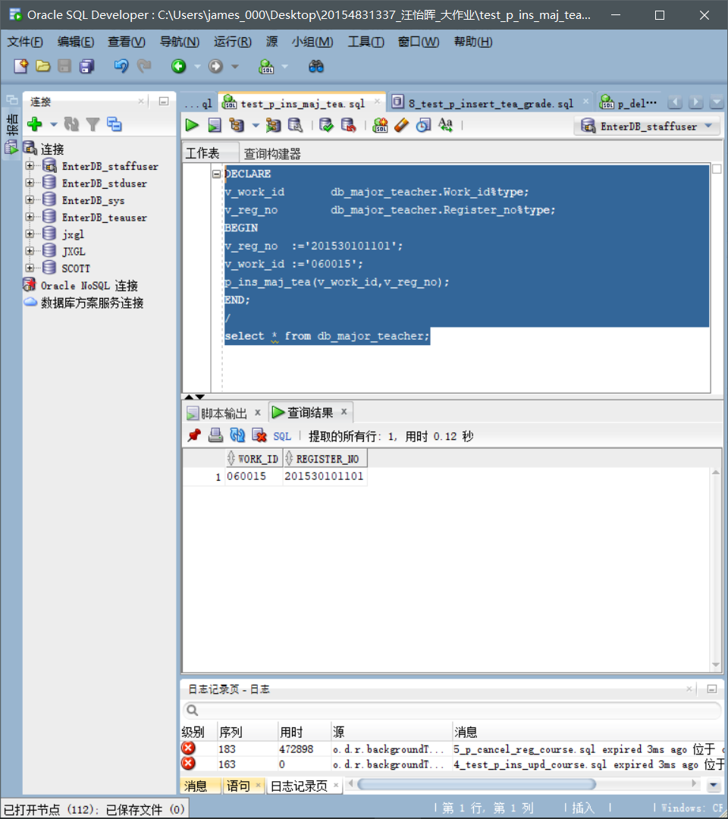

1. **Test script: tests p_dele_maj_std** .

set serveroutput on.

DECLARE.

v_work_id db_major_teacher.work.id%type default '060015';

v_reg_no db_major_teacher.register.no%type default '20153010101';

BEGIN.

p_dele_maj_std (v_work_id, v_reg_no);

END;

/

select s from db_major_teacher;

**What to test:**

For teachers with work number 060015, remove the school number 201530101101 for the tutoring students.

**Screenshots:**

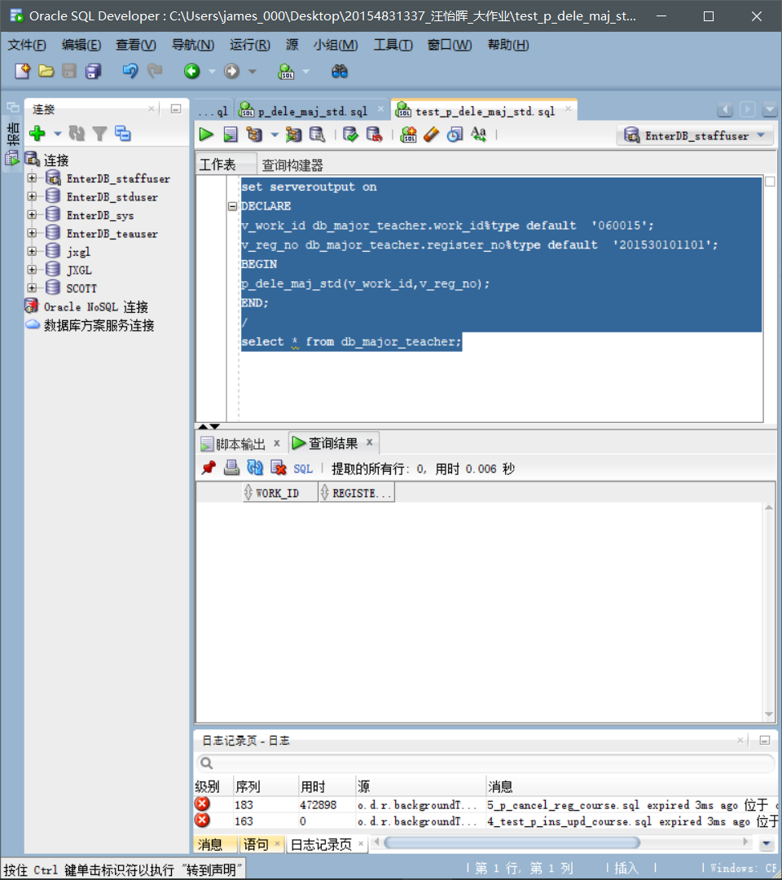

1. **Test script: tests**  **p_std_tot_gpa** .

set serveroutput on.

DECLARE.

v_reg_no db_grade.register.no%type default '201530101101';

v_gpa number;

BEGIN.

p_std_tot_gpa (v_reg_no, v_gpa);

DBMS_OUTPUT. PUT_LINE ('Study No.:''''''''''''''''''''''''' v_reg_no);

DBMS_OUTPUT. PUT_LINE ('GPA:'''''''''''''''''''''''''' v_gpa);

END;

/

**What to test:**

The GPAof the student sat with the query number 201530101101.

**Screenshots:**

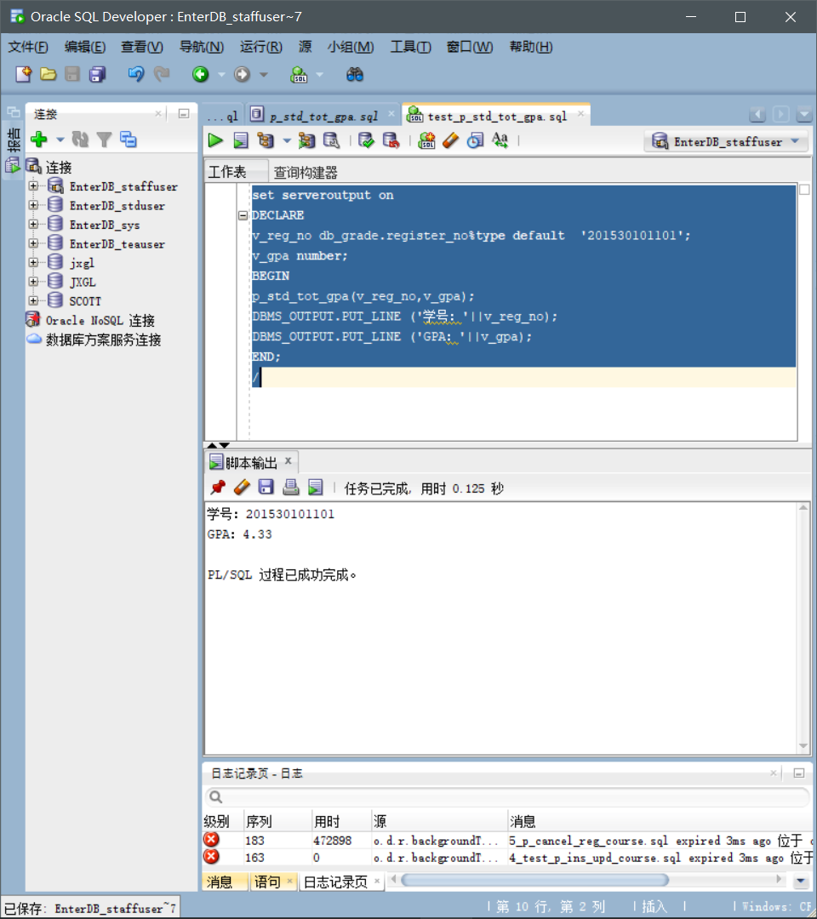

**1. Store the procedure.**

**Test script:1_test_p_query_std_inf.sql.**

set serveroutput on.

DECLARE.

v_reg_no db_student.register.no-type default '20153010101';

v_name db_student.s.name-type;

v_birthday db_student.s.dateofbirth%type;

v_address db_student.s.address%type;

v_postcode db_student.s-postcode%type;

v_mail_address db_student.s?mail?address%type;

v_tele db_student.s?tele%type;

v_email db_student.s.email%type;

BEGIN.

p_query_std_inf (v_reg_no, v_name, v_birthday, v_address, v_postcode, v_mail_address, v_tele, v_email);

DBMS_OUTPUT. PUT_LINE ('Study No.:''''''''''''''''''''''''' v_reg_no);

DBMS_OUTPUT. PUT_LINE ('Name:'''''''''''''''''''''''' v_name);

DBMS_OUTPUT. PUT_LINE ('Birthday:'''''''''''''''''''''''' v_birthday);

DBMS_OUTPUT. PUT_LINE ('Home Address:'''''''''''''''''''''''''' v_address);

DBMS_OUTPUT. PUT_LINE ('Postcode:''''''''''""""""""""""" v_postcode);

DBMS_OUTPUT. PUT_LINE ('mail address:'''''''''''''''''''''''''' v_mail_address);

DBMS_OUTPUT. PUT_LINE ('Contact Phone:'''''''''''''''''''''''''' v_tele);

DBMS_OUTPUT. PUT_LINE ('E-Mail:''''''''''''''''''''''''' v_email);

END;

/

**What to test:**

Check the personal information of students with the study number 20153010101.

**Screenshots:**

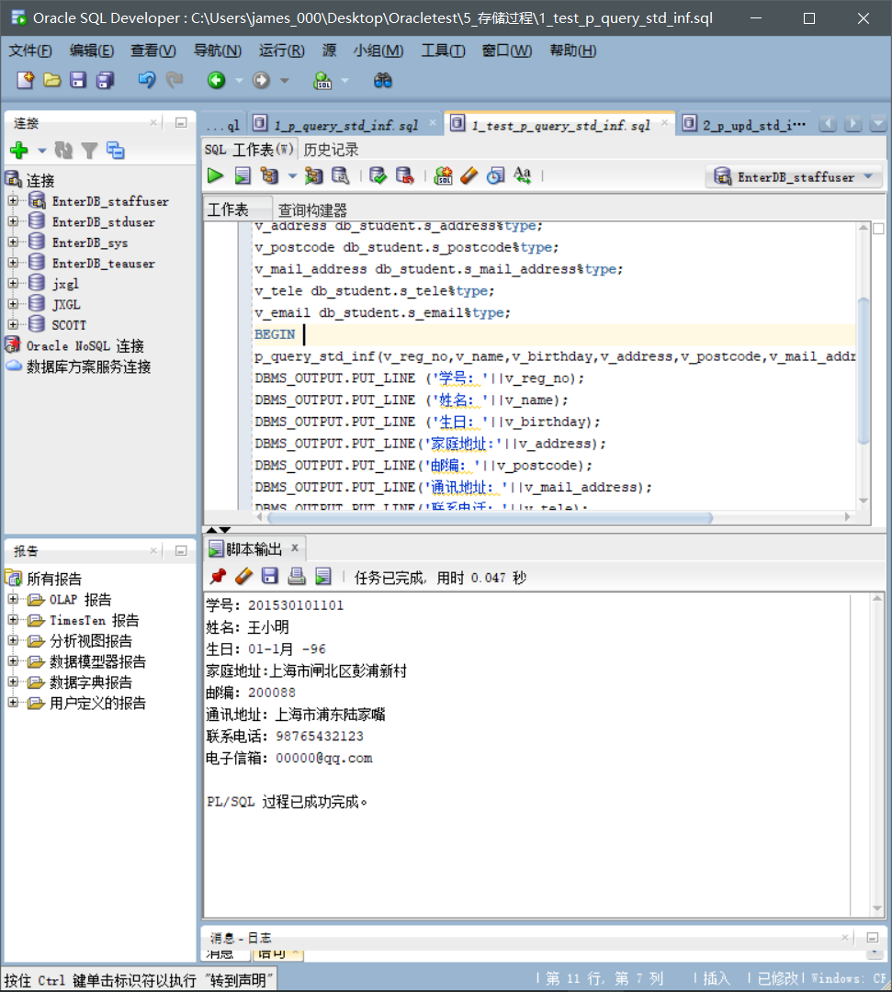

**Test script:2_test_p_upd_std_inf.sql.**

set serveroutput on.

DECLARE.

v_reg_no db_student.register-no-type;

v_name db_student.s.name-type;

v_birthday db_student.s.dateofbirth%type;

v_address db_student.s.address%type;

v_postcode db_student.s-postcode%type;

v_mail_address db_student.s?mail?address%type;

v_tele db_student.s?tele%type;

v_email db_student.s.email%type;

BEGIN.

v_reg_no: '201530101101';

v_name: 'Zhang Daming';

v_birthday: '06-June-00';

v_address: 'Caolu Town, Pudong New Area, Shanghai';

v_postcode: '255588';

v_mail_address: 'Five-corner field in Yangpu District, Shanghai';

v_tele: '00000001111';

v_email:='666@qq.com';

p_upd_std_inf (v_reg_no, v_name, v_birthday, v_address, v_postcode, v_mail_address, v_tele, v_email);

commit;

END;

/

select from db_student where register_no'20153010101';

**What to test:**

The personal information of students with revised school number 2015301010101.

**Screenshots:**

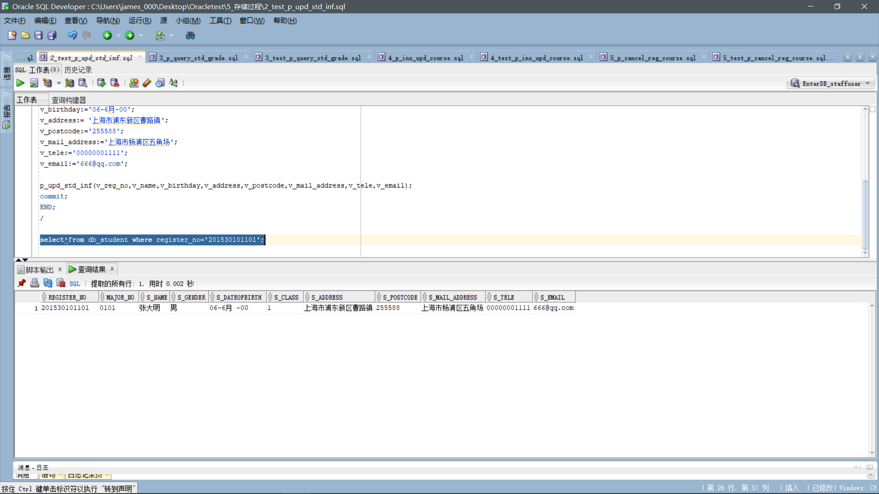

**Test script:3_test_p_query_std_grade.sql.**

set serveroutput on.

DECLARE.

v_reg_no db_grade.register.no%type default '201530101101';

v_course_name db_grade.course.name-type default 'computer network';

v_final_grade db_grade.final?grade%type;

BEGIN.

p_query_std_grade (v_reg_no, v_course_name, v_final_grade);

DBMS_OUTPUT. PUT_LINE ('Study No.:''''''''''''''''''''''''' v_reg_no);

DBMS_OUTPUT. PUT_LINE ('course name:'?' v_course_name);

DBMS_OUTPUT. PUT_LINE ('Grades:'''''''''''''''''''''''' v_final_grade);

END;

/

**What to test:**

Check the test scores of the Computer Network course for students with the 201530101101.

**Screenshots:**

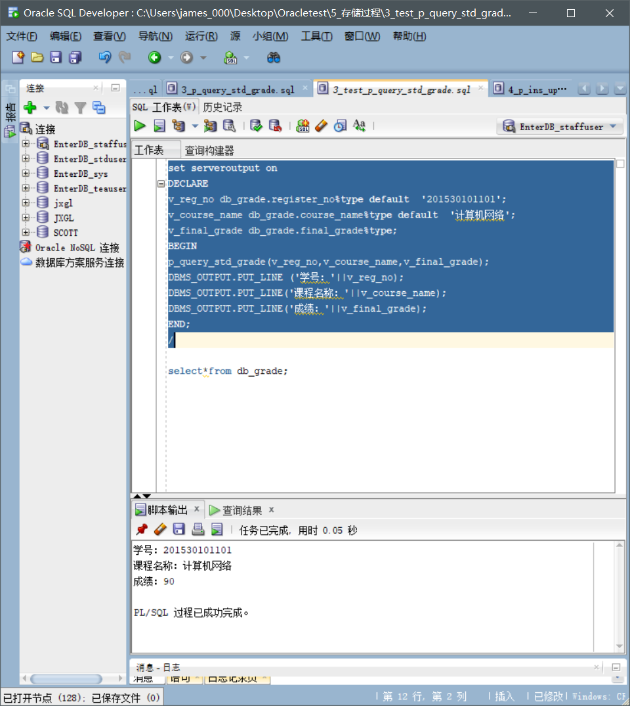

**Test script:4_test_p_ins_upd_course.sql** .

DECLARE.

v_reg_no db_grade. Register_no%type;

v_course_no db_grade.course-no%type;

v_course_name db_grade.course.name%type;

v_work_id db_grade. Work_id% type;

v_college_no db_grade.course-name-type;

v_reg_date db_grade. Registered_date% type;

v_reg_year db_grade. Registered_year%type;

v_reg_term db_grade. Registered_term% type;

v_credit db_grade.credit%type;

BEGIN.

v_reg_no: '201530101102';

v_course_no: 'CS270';

v_course_name: 'Data Structure';

v_work_id: '07001';

v_college_no: '04';

v_reg_date: sysdate;

v_reg_year: '2017-2018';

v_reg_term: ''1';

v_credit: : 2.5;

p_ins_upd_course (v_reg_no, v_course_no, v_course_name, v_work_id,

v_college_no, v_reg_date, v_reg_year, v_reg_term, v_credit);

END;

/

select-from db_grade;

**What to test:**

Select a course number "CS270"for students with the number 201530101102,acoursename for "Data Structure" and a course number of "070001".

**Screenshots:**

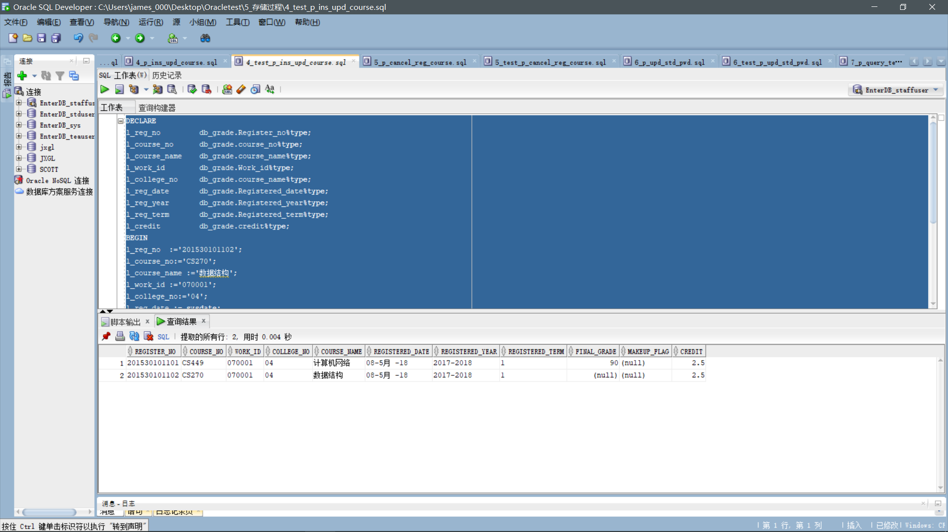

**Test script:5_test_p_cancel_reg_course.sql** .

set serveroutput on.

DECLARE.

v_reg_no db_grade.register?no%type default '201530101102';

v_course_no db_grade.course?no%type default 'CS270';

v_work_id db_grade.work.id%type default '070001';

BEGIN.

p_cancel_reg_course (v_reg_no, v_course_no, v_work_id);

END;

/

select s from DB_GRADE;

**What to test:**

The course number "C S270" and the teacher's work number "070001" were cancelled for students with thenumber "CS270"for students with the number 20153010102. 2015301011

**Screenshots:**

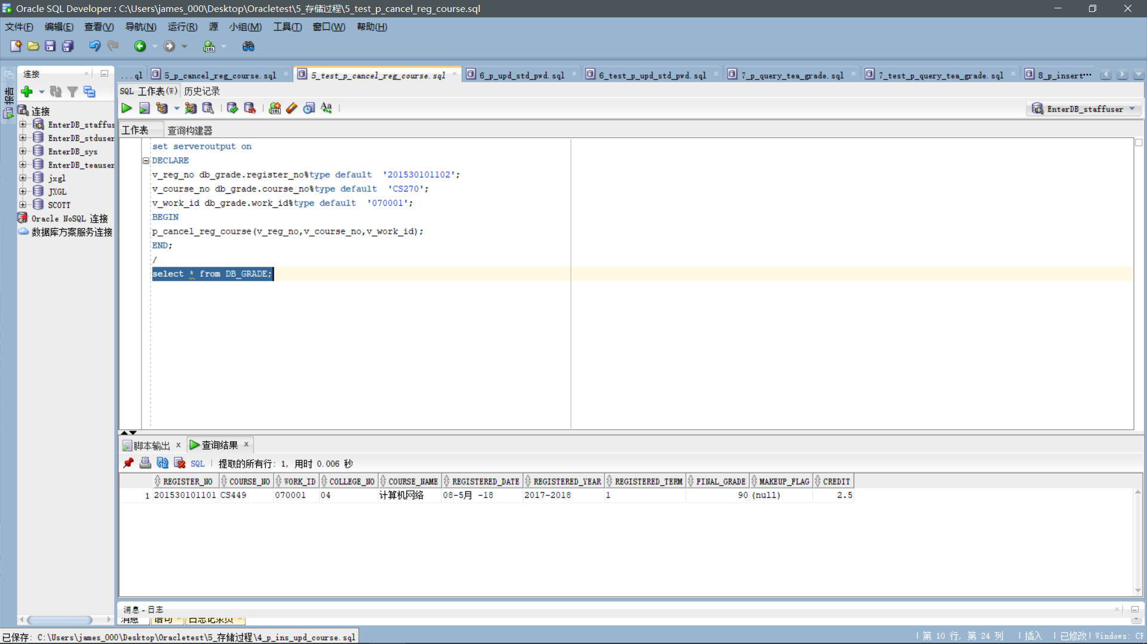

**Test script:6_test_p_upd_std_pwd.sql.**

set serveroutput on.

DECLARE.

v_reg_no DB_STUDENT_PER.register-no-type;

v_password DB_STUDENT_PER. LOGIN_PWD_S% type;

v_password_new DB_STUDENT_PER. LOGIN_PWD_S% type;

BEGIN.

v_reg_no: '201530101101';

v_password: '123456';

v_password_new: '666666';

p_upd_std_pwd (v_reg_no, v_password, v_password_new);

commit;

END;

/

select s from DB_STUDENT_PER;

**What to test:**

Change the password of a student with the school number 2015301011 011to 66666.

**Screenshots:**

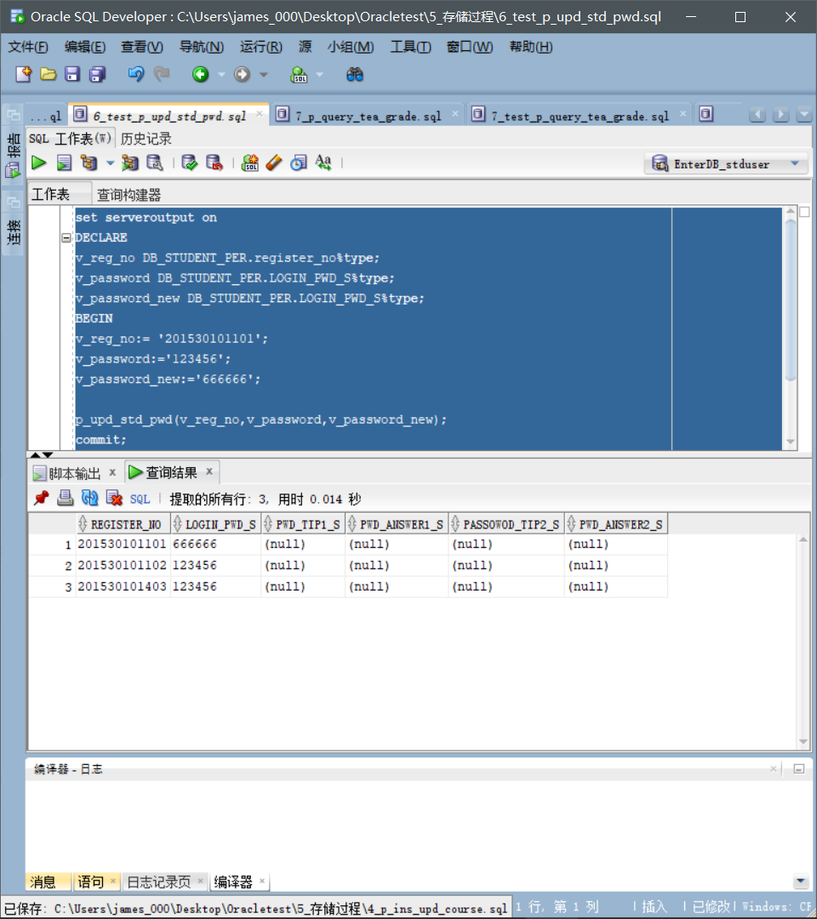

**Test script:7_test_p_query_tea_grade.sql** .

set serveroutput on.

DECLARE.

v_reg_no db_grade.register.no%type default '201530101101';

v_work_id db_grade.work?id%type default '070001';';

v_course_name db_grade.course?name-type default 'computer network';

v_final_grade db_grade.final?grade%type;

BEGIN.

p_query_tea_grade (v_reg_no, v_work_id, v_course_name, v_final_grade);

DBMS_OUTPUT. PUT_LINE ('Study No.:''''''''''''''''''''''''' v_reg_no);

DBMS_OUTPUT. PUT_LINE ('Teacher's Work No.:''''''''''''''''''''''''' v_work_id);

DBMS_OUTPUT. PUT_LINE ('course name:'?' v_course_name);

DBMS_OUTPUT. PUT_LINE ('Grades:'''''''''''''''''''''''' v_final_grade);

END;

/

**What to test:**

The course name of the student scored for the course number 2015301011 011is "Computer Network" and the test result of thecourse with the teacher's number "070001".

**Screenshots:**

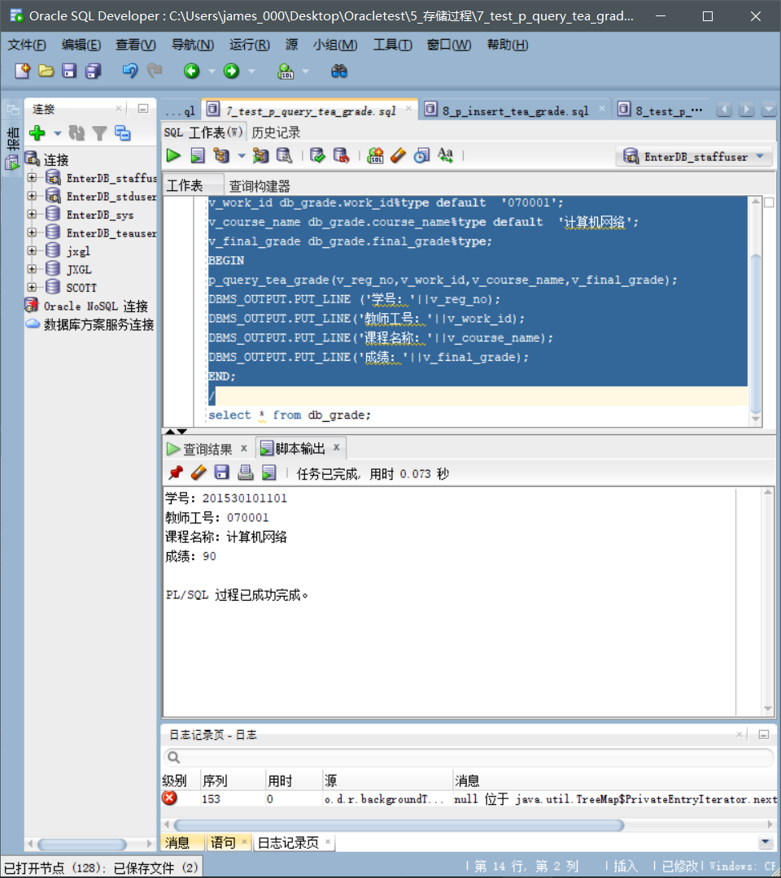

**Test script:8_test_p_insert_tea_grade.sql** .

DECLARE.

v_reg_no db_grade. Register_no%type;

v_course_no db_grade.course-no%type;

v_course_name db_grade.course.name%type;

v_work_id db_grade. Work_id% type;

v_college_no db_grade.course-name-type;

v_reg_date db_grade. Registered_date% type;

v_reg_year db_grade. Registered_year%type;

v_reg_term db_grade. Registered_term% type;

v_final_grade db_grade.final?grade%type;

v_credit db_grade.credit%type;

BEGIN.

v_reg_no: '20153010101';

v_course_no: 'CS328';

v_course_name: 'The principle of computer composition';

v_work_id: '060015';

v_college_no: '04';

v_reg_date: sysdate;

v_reg_year: '2017-2018';

v_reg_term: ''1';

v_final_grade: '98';

v_credit: : 2.5;

p_insert_tea_grade (v_reg_no, v_course_no, v_course_name, v_work_id,

v_college_no, v_reg_date, v_reg_year, v_reg_term, v_final_grade, v_credit);

END;

/

select s from DB_GRADE;

**What to test:**

Thecourse number of "CS328" for studentswith the number 2015301011 0111is"CS328",the course name is "Computer Composition Principle" andthe course number"060015"is entered with a score of 98.

**Screenshots:**

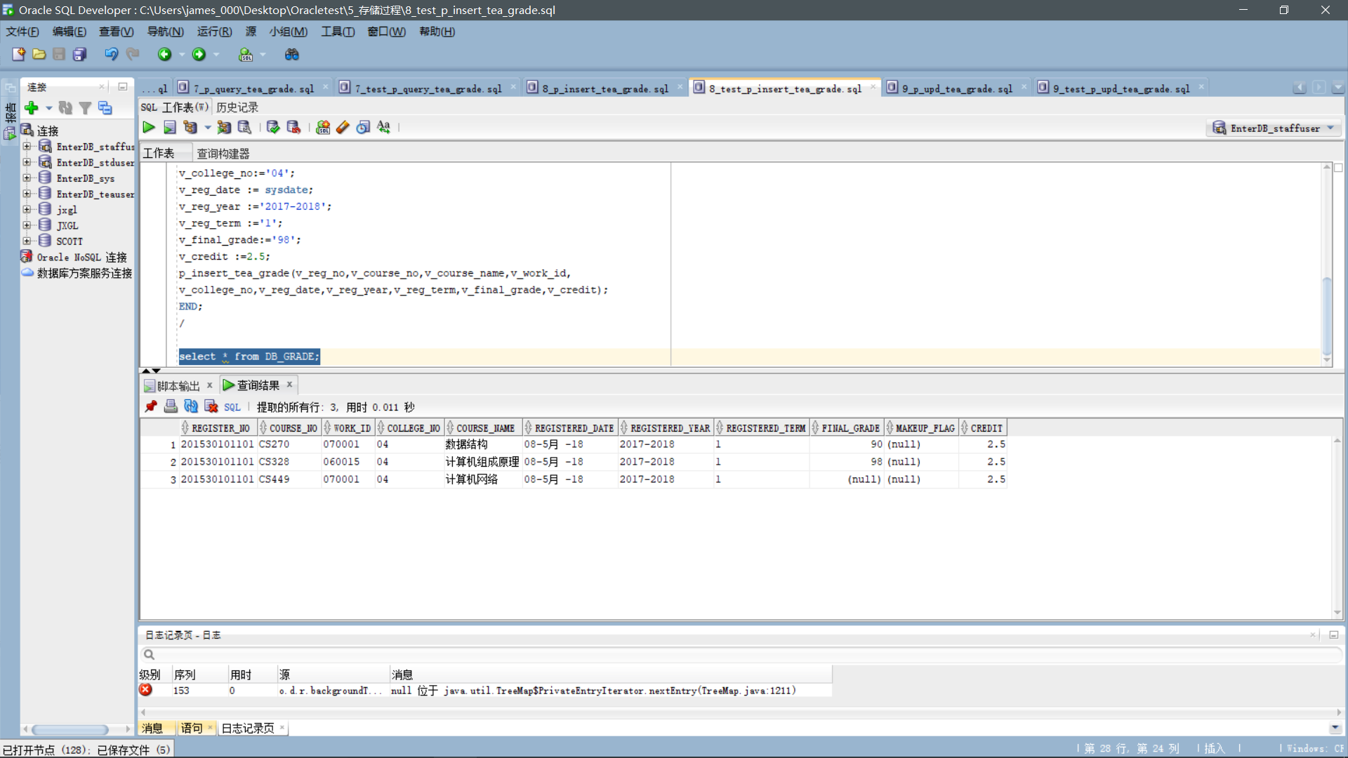

**Test script:9_test_p_upd_tea_grade.sql.**

DECLARE.

l_reg_no db_grade. Register_no%type;

l_course_no db_grade.course-no%type;

l_course_name db_grade.course-name-type;

l_work_id db_grade. Work_id% type;

l_college_no db_grade.course.name%type;

l_reg_year db_grade. Registered_year%type;

l_reg_term db_grade. Registered_term% type;

l_final_grade db_grade.final?grade%type;

l_credit db_grade.credit%type;

BEGIN.

l_reg_no: '201530101101';

l_course_no: 'CS449';

l_course_name: 'Computer network';

l_work_id: '07001';

l_college_no: '04';

l_reg_year: '2017-2018';

l_reg_term: s1';

l_final_grade: '92';

l_credit: s2.5;

p_upd_tea_grade (l_reg_no, l_course_no, l_course_name, l_work_id,

l_college_no, l_reg_year, l_reg_term, l_final_grade, l_credit);

END;

/

select s from DB_GRADE;

**What to test:**

The course number"CS449"for studentswith the number 2015301011 0111was revised to 92 points for courseswith the course name "Computer Network" and"070001"for theteacher."

**Screenshots:**

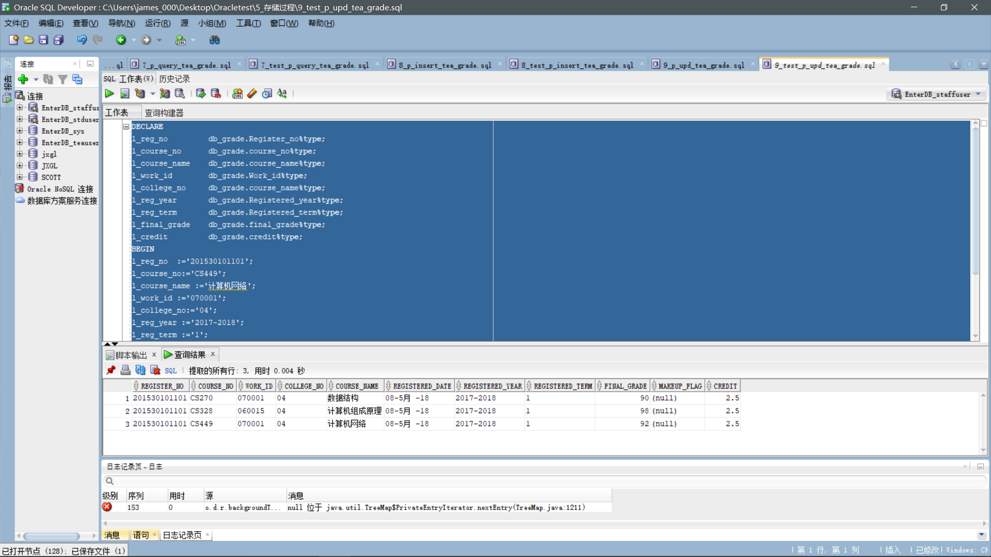

**Test script:10_test_p_upd_tea_pwd.sql.**

set serveroutput on.

DECLARE.

v_work_id db_faculty_per.work?id%type;

v_password db_faculty_per. LOGIN_PWD_F%type;

v_password_new db_faculty_per. LOGIN_PWD_F%type;

BEGIN.

v_work_id: '020013';

v_password: '123456';

v_password_new: '666666';

p_upd_tea_pwd (v_work_id, v_password, v_password_new);

commit;

END;

/

select s from db_faculty_per;

**What to test:**

Change the password of the teacher with work number 020013 to 666666.

**Screenshots:**

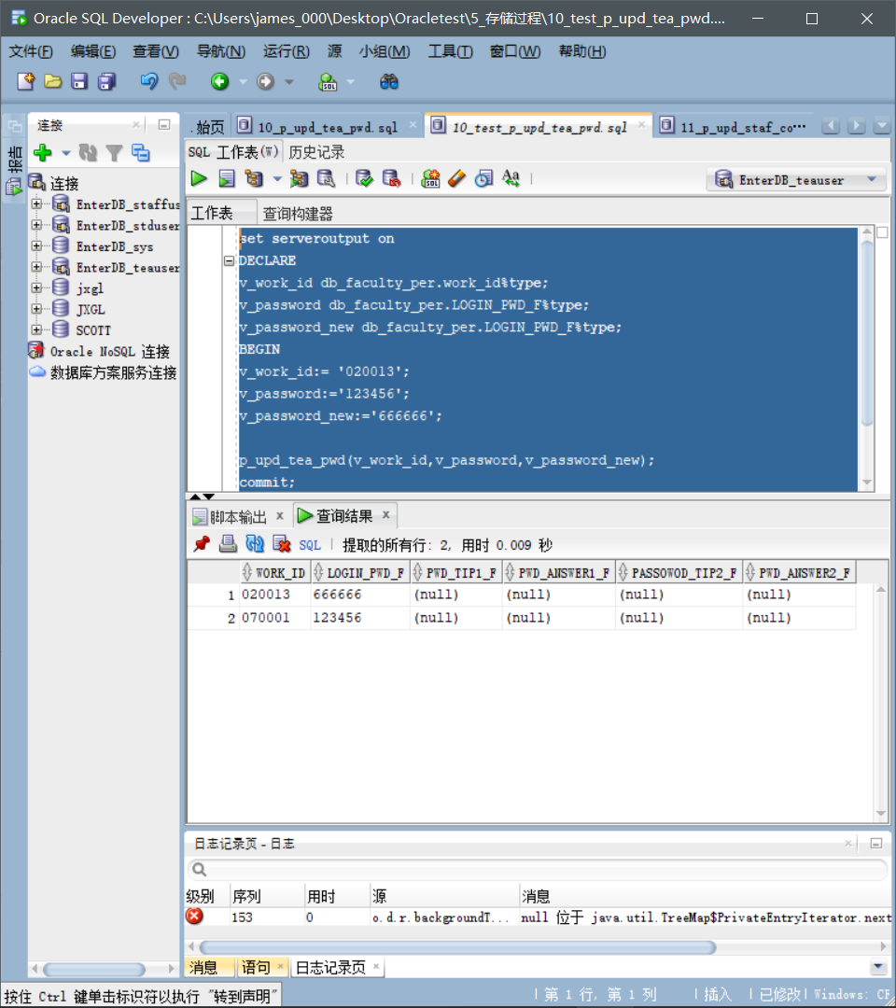

**Test script:11_test_p_upd_staf_course.sql.**

set serveroutput on.

DECLARE.

v_work_id db_teach_course.work?id%type;

v_course_no db_teach_course.course-no%type;

v_course_no_new db_teach_course.course-no%type;

v_course_name db_teach_course.course.name%type;

BEGIN.

v_work_id: '050011';

v_course_no: 'PHY638';

v_course_no_new: 'CS243';

v_course_name: 'Compilation Principle';

p_upd_staf_course (v_work_id, v_course_no, v_course_no_new, v_course_name);

commit;

END;

/

select s from db_teach_course;

**What to test:**

Change the teaching plan of a teacher with the number 050011 to a course number "CS243" and the course name "Compilation Principles".

**Screenshots:**

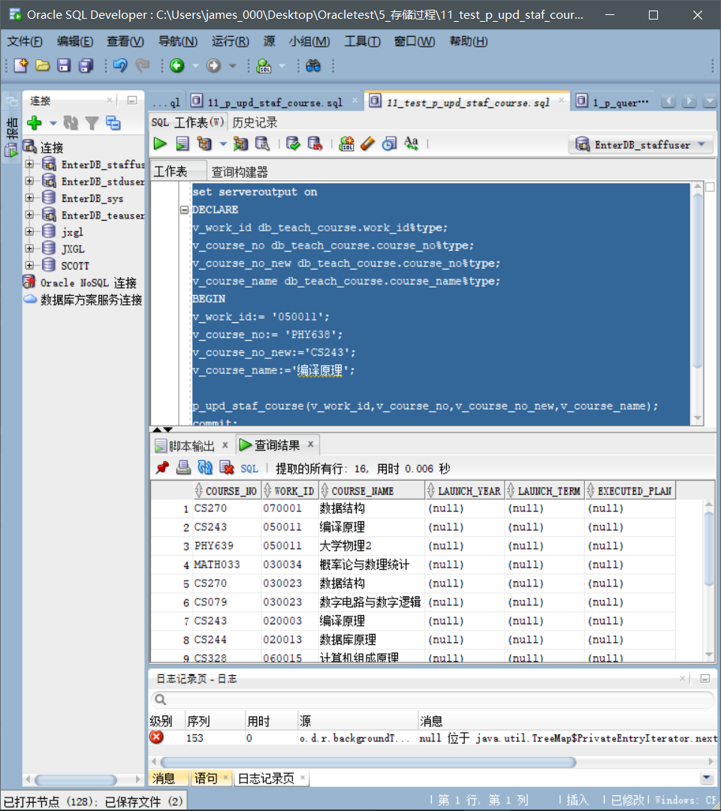

**2. . .** **The function** .

**1_fun_query_std_gra.sql.**

set serveroutput on.

begin.

DBMS_OUTPUT. PUT_LINE (fun_query_std_gra ('201530101101', 'CS449', '070001););

End;

**What to test:**

The course number for the studentswith the inquiry number 2015301011101 is "CS449"and the teacher's work number is "070001" for the individual exam results.

**Screenshots:**

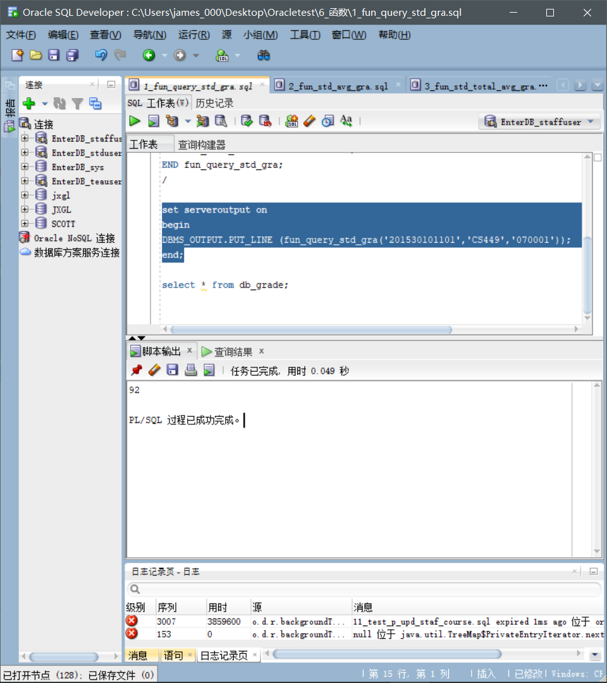

**2_fun_std_avg_gra.sql.**

set serveroutput on.

begin.

DBMS_OUTPUT. PUT_LINE (fun_std_avg_gra ('201530101101,'1'),2);

End;

**What to test:**

The average test scores for students in the first semester of the query number 201530101101.

**Screenshots:**

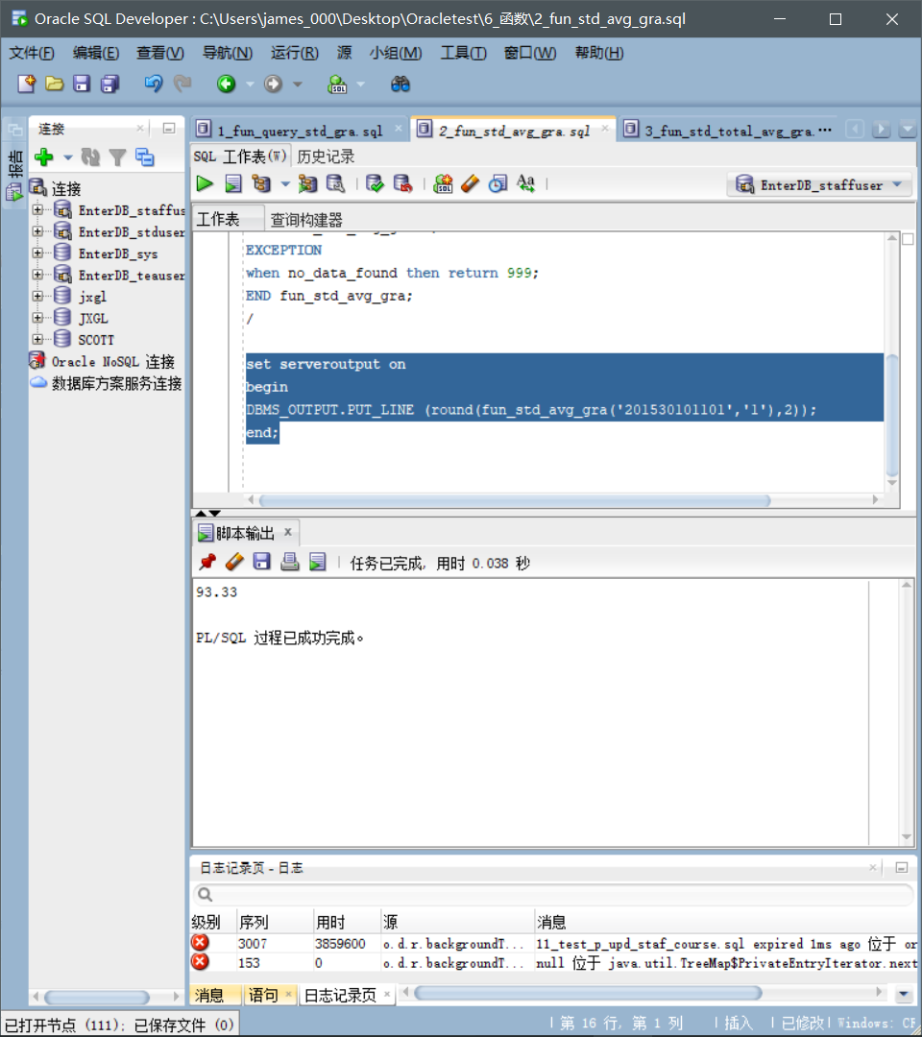

**3_fun_std_total_avg_gra.sql.**

set serveroutput on.

begin.

DBMS_OUTPUT. PUT_LINE (fun_std_total_avg_gra ('201530101101),2);

End;

**What to test:**

Check the average scores of all students with the study number 201530101101.

**Screenshots:**

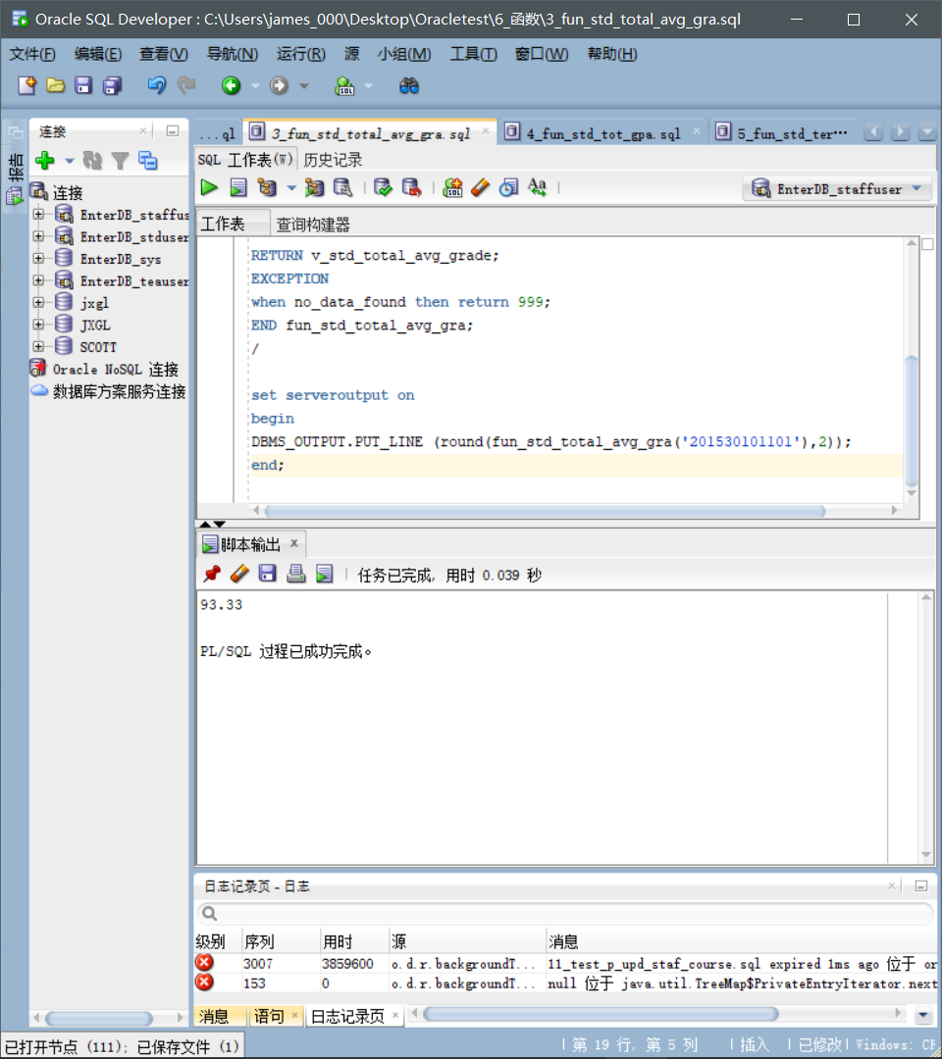

**4_fun_std_tot_gpa.sql.**

set serveroutput on.

begin.

DBMS_OUTPUT. PUT_LINE (fun_std_tot_gpa ('201530101101),2);

End;

**What to test:**

Query The GPAof the student son of 2015301010101.

**Screenshots:**

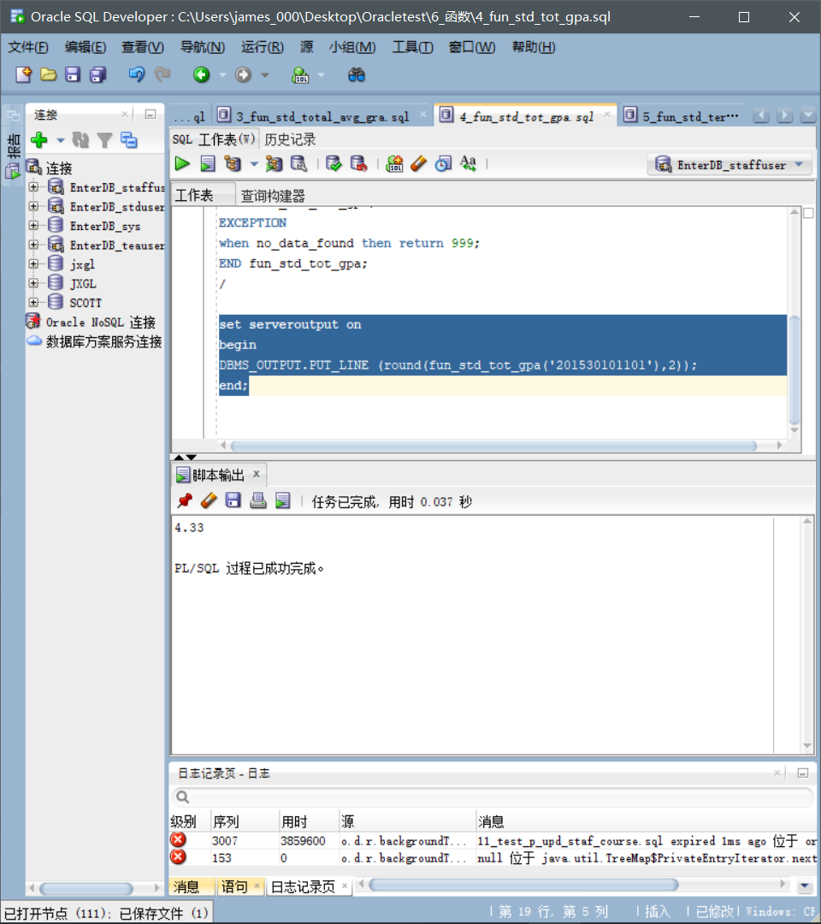

**5_fun_std_term_avg_gra.sql.**

set serveroutput on.

begin.

DBMS_OUTPUT. PUT_LINE (fun_std_term_avg_gra (fun_std_term_avg_gra ('0303', '1'),2);

End;

**What to test:**

Check the average grades of first semester students in the major number "0303".

**Screenshots:**

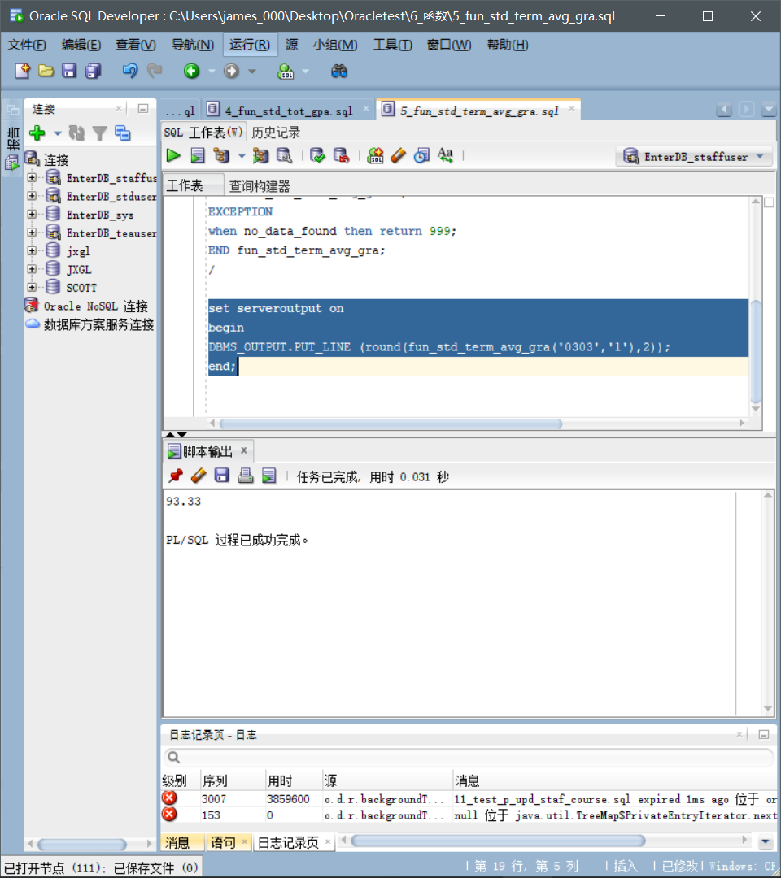

**3. . .** **The trigger.**

**1_tri_startup_db.sqlsamp;2_tri_shutdown_db.sql.**

Select from updown_log;

**What to test:**

Record when the database started and closed, and the user.

**Screenshots:**

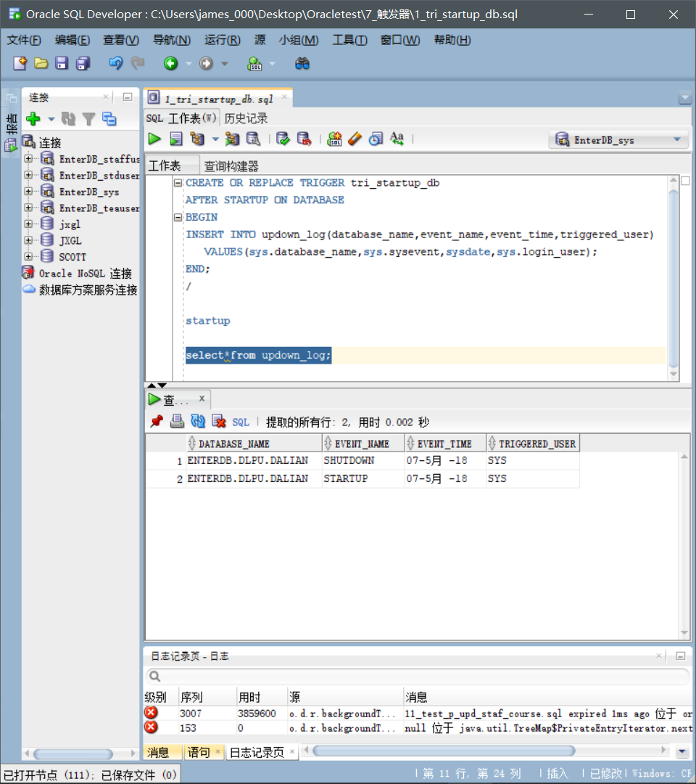

**3_tri_login_user.sql.4_tri_logout_user.sql.**

Select from user_login_log;

**What to test:**

Automatically log on and log off the system's user information, including IP,host name, login time, user name, etc.

**Screenshots:**

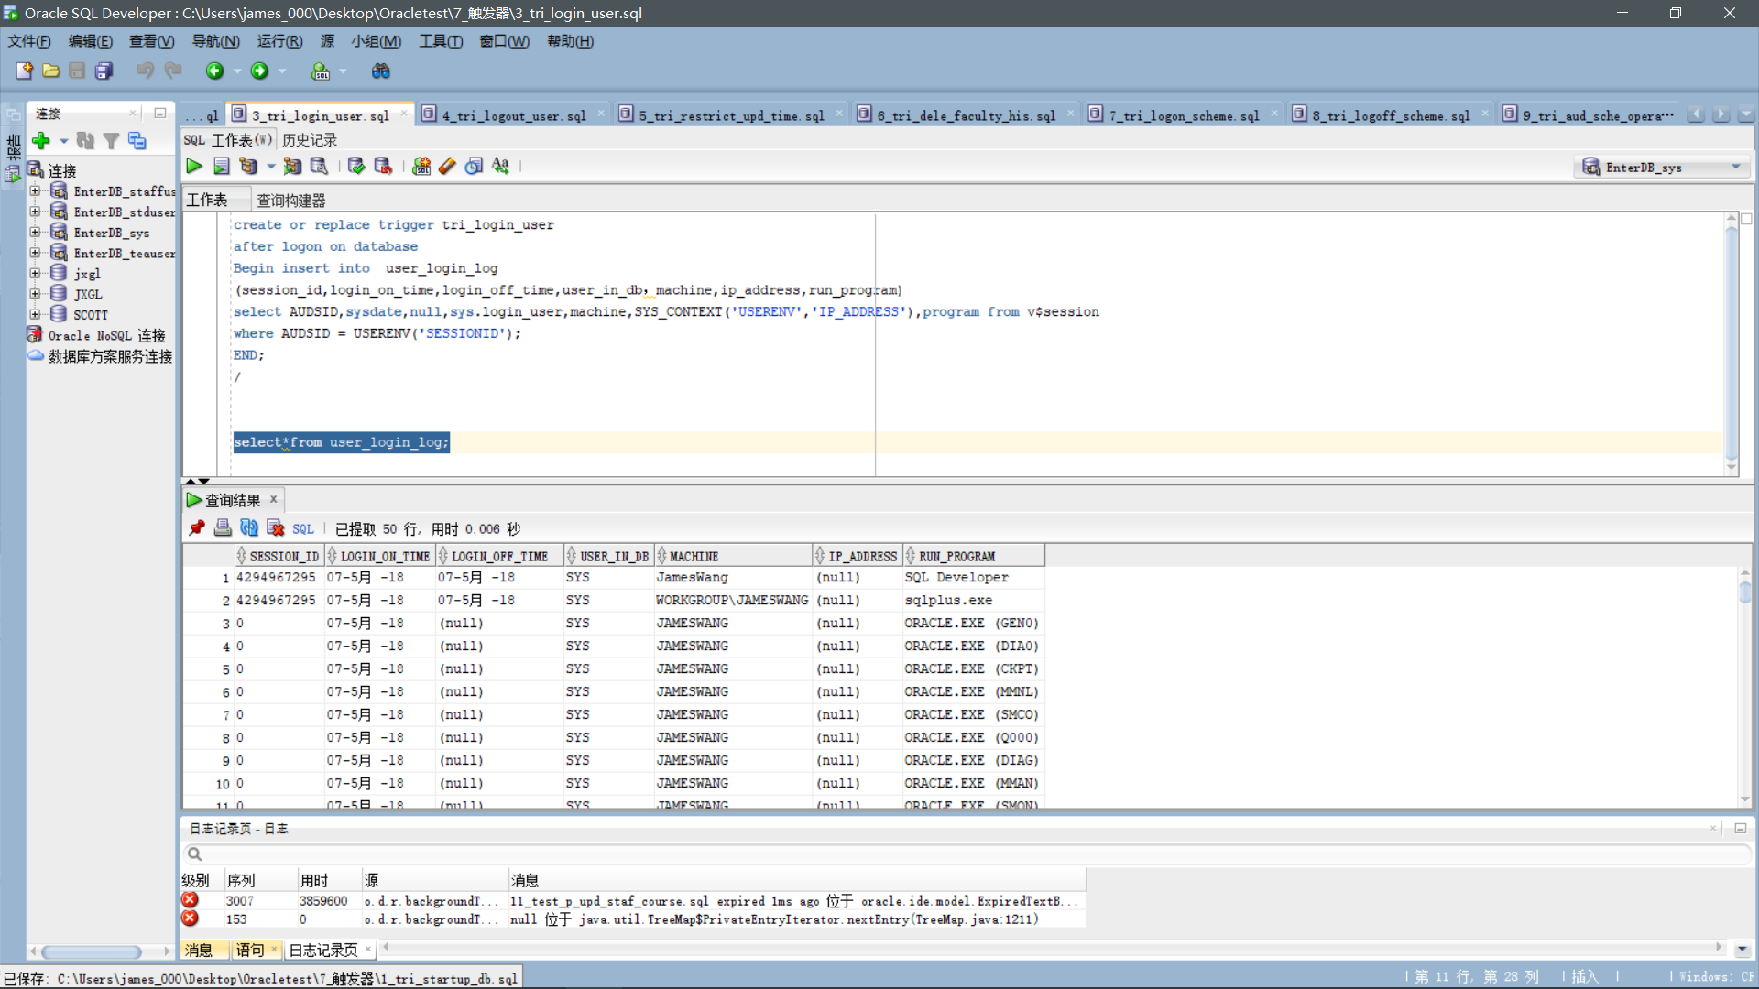

**5_tri_restrict_upd_time.sql.**

**What to test:**

Set system time to 12:01 p.m. on Sunday, and the test cannot be modified for the database db_the grade table on Saturday and Sunday from 8 a.m. to 5 p.m.

**Screenshots:**

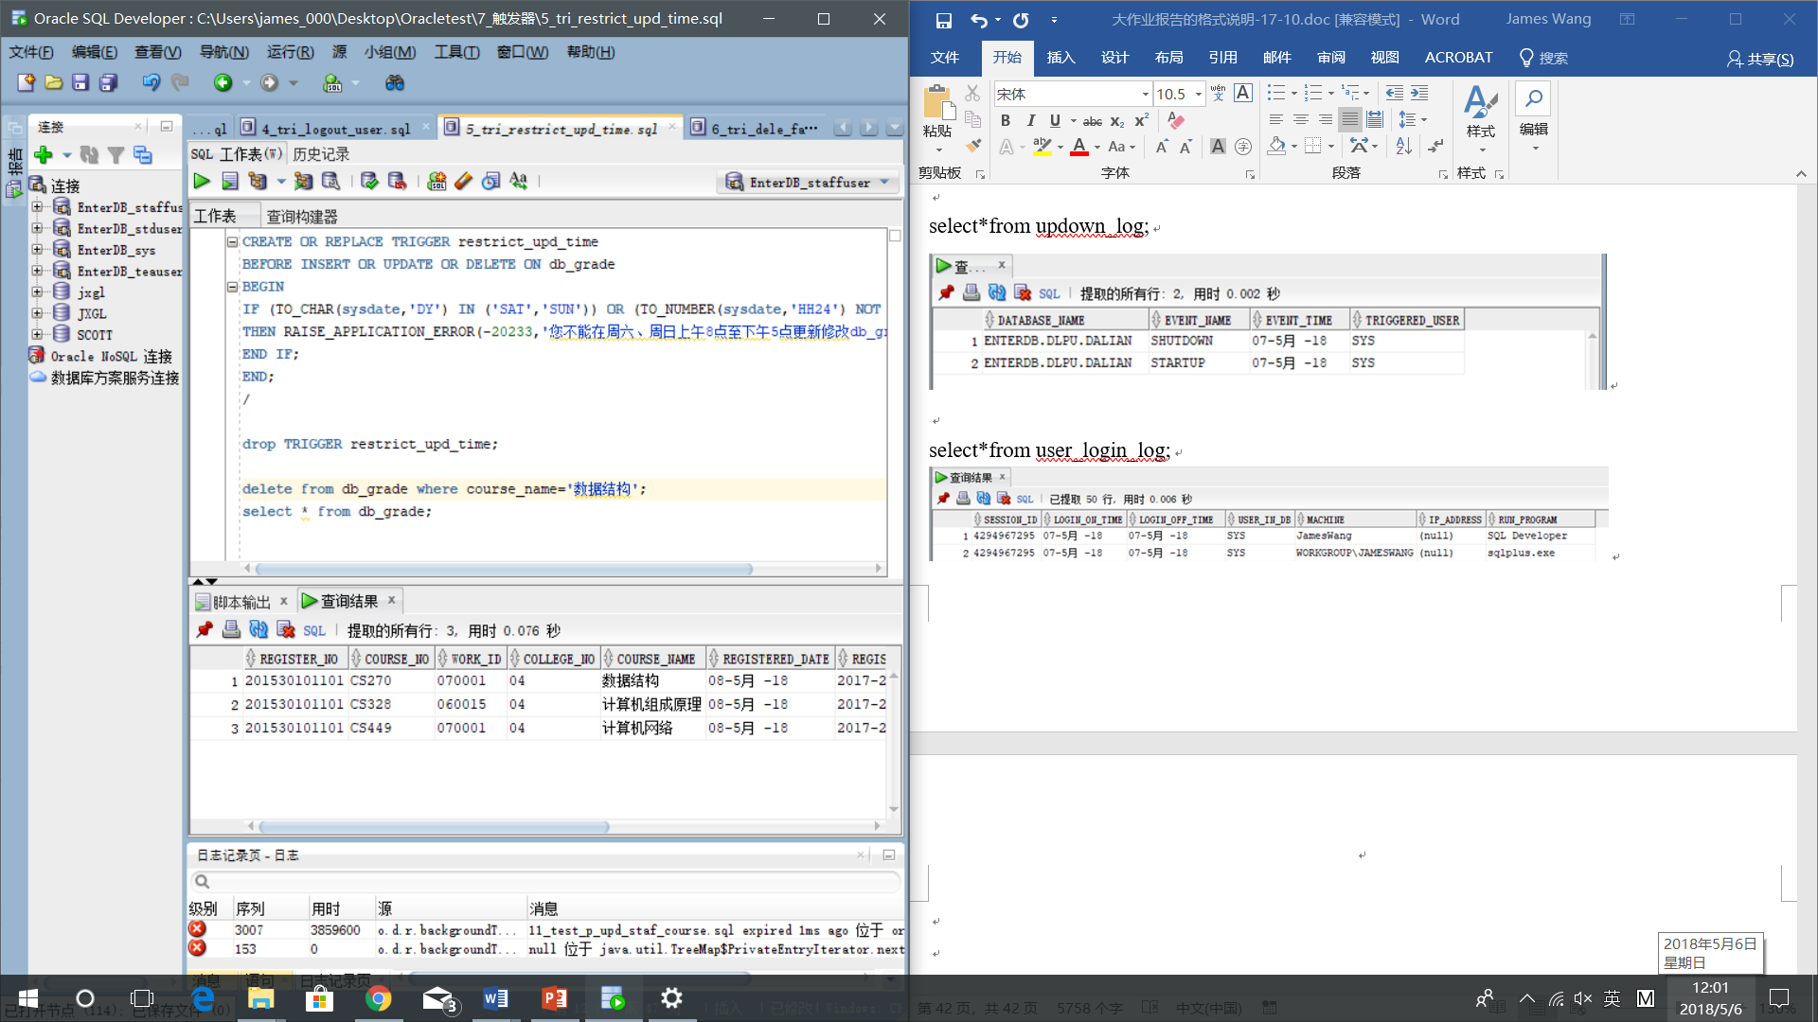

delete from db_grade where course_name', 'data structure';

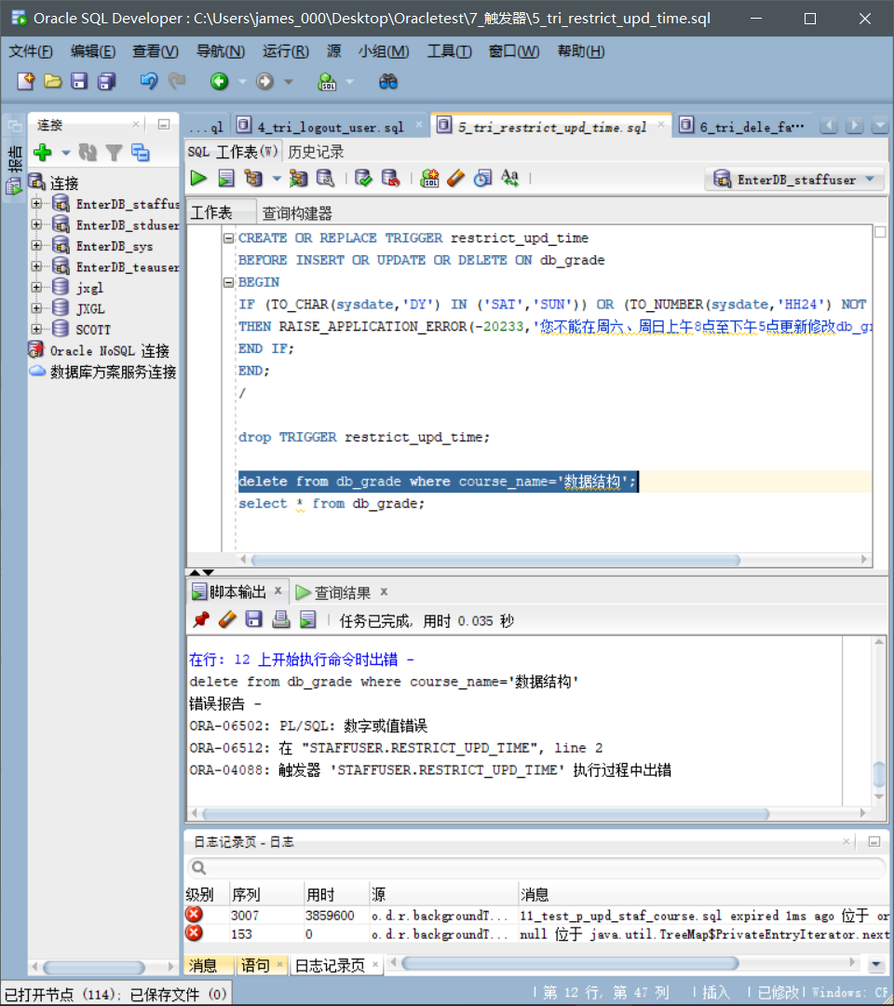

**6_tri_dele_faculty_his.sql.**

Select from db_dele_faculty;

**What to test:**

Remove teachers whose names are "stone methods" and automatically record information about departing teachers.

**Screenshots:**

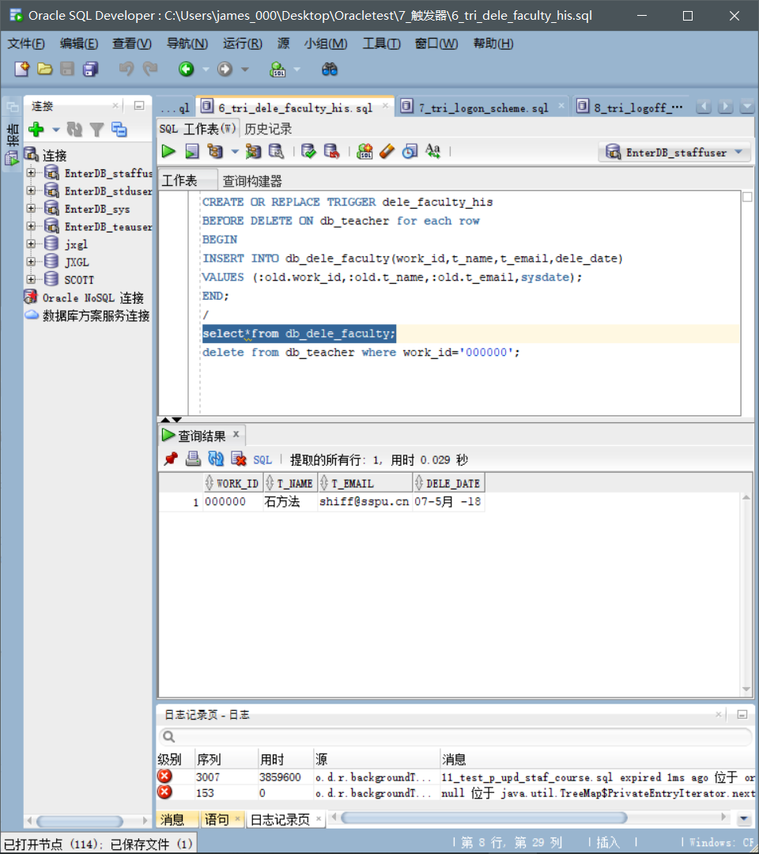

**7_tri_logon_scheme.sql.8_tri_logoff_scheme.sql.**

SELECT: FROM db_log_event;

**What to test:**

The system automatically records user information when logging in or off.

**Screenshots:**

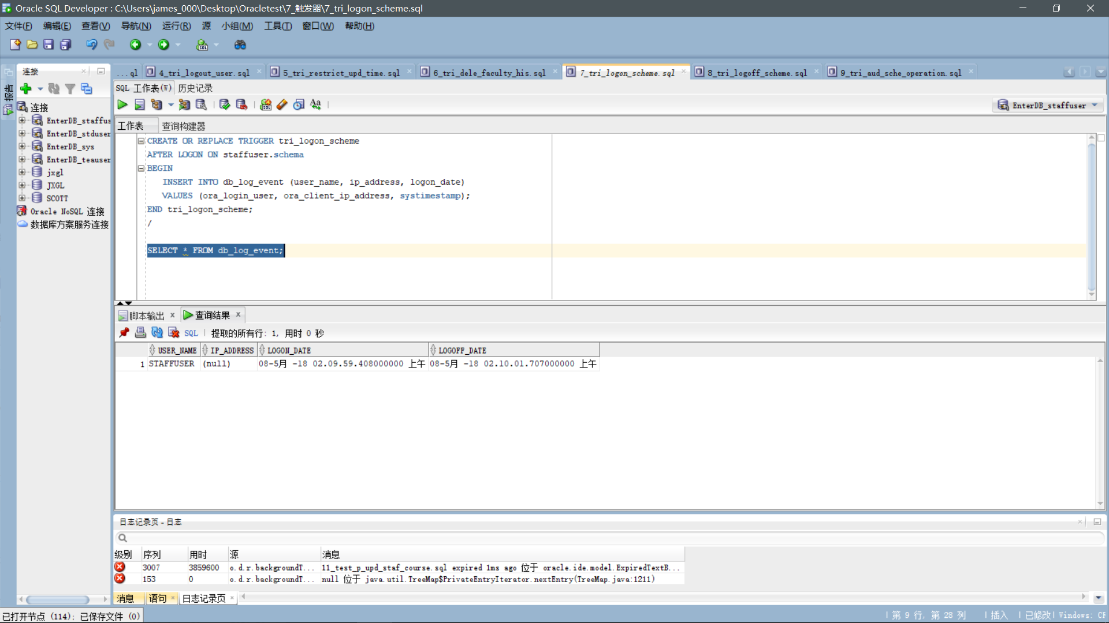

**9_tri_aud_sche_operation.sql.**

Select from db_scheme_activities;

**What to test:**

The user's DLL action is automatically logged.

**Screenshots:**

